
Weekly Newsletter
W.B. 29.1.24

Please can we ask that any reading books taken home are returned to your child’s classroom book boxes after they’ve been used.

This week:

As part of English this week we have continued their second cycle of story writing. The children have learnt about the prefix ‘un’ which is added to the start of a root word to change the meaning by giving it an opposite/negative force. We can often say the opposite of a word by adding ‘un’ for example, kind = unkind and friendly = unfriendly. There are no spelling rules for adding the prefix ‘un’ so the children simply applied it to the start of a bank of words and then used these within their sentence writing.

After that, children created a story plan including pictures and key words to support them when writing their story based on the short Pixar film ‘For the birds’. In our following English lessons, the children wrote the start of their story using the story language ‘In a land far away…’ and the build-up of their story which began with ‘It was a ____ _____ morning…’.

Can your child re-tell you the ‘start’ of their story?
Can your child tell you the story language we use for the ‘build up’ of a story?

As part of Maths this week children have started learning about time. We revisited the ‘days of the week’ and ‘months of the year’ before looking at our daily routines. Children sequenced pictures to show the order they would usually do things for example, first get up, then have breakfast, after that go to school.

Can your child name something they do in between lunchtime and bedtime?

We then learnt how to tell the time on an analogue clock. In Year 1, we learn to tell the time to the hour and half past the hour. Please look at the information below with your child.

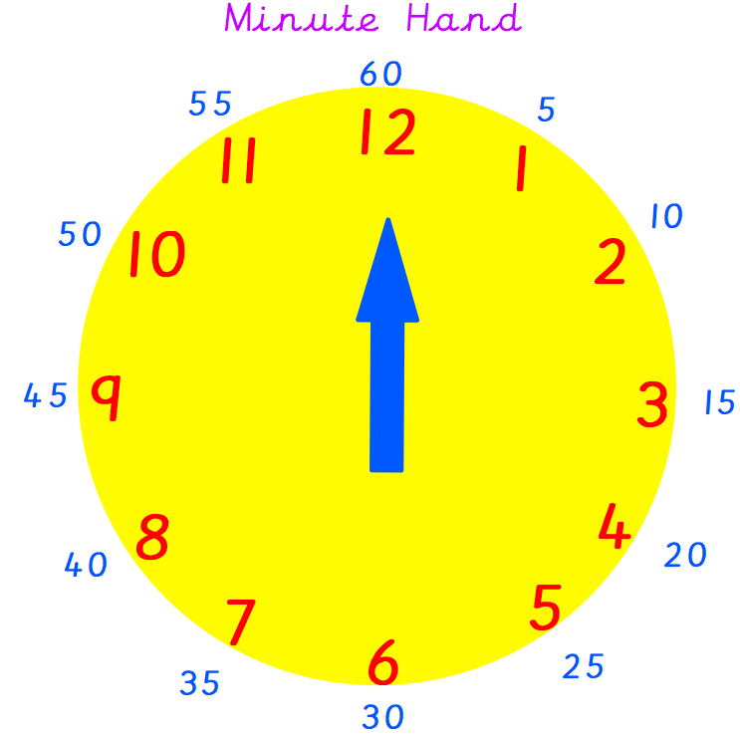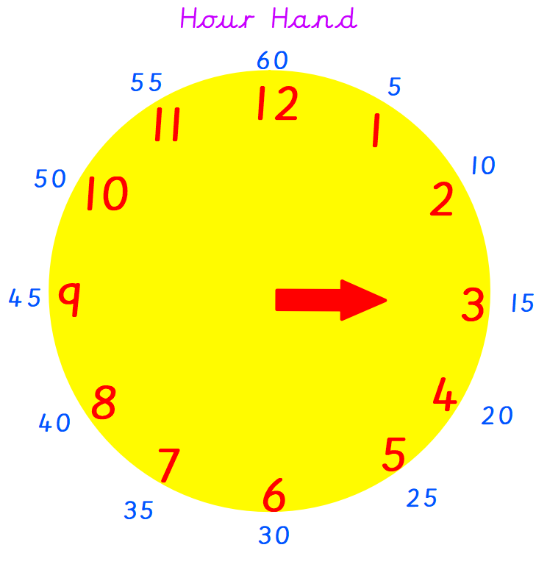
The minute hand is longer than the hour hand.
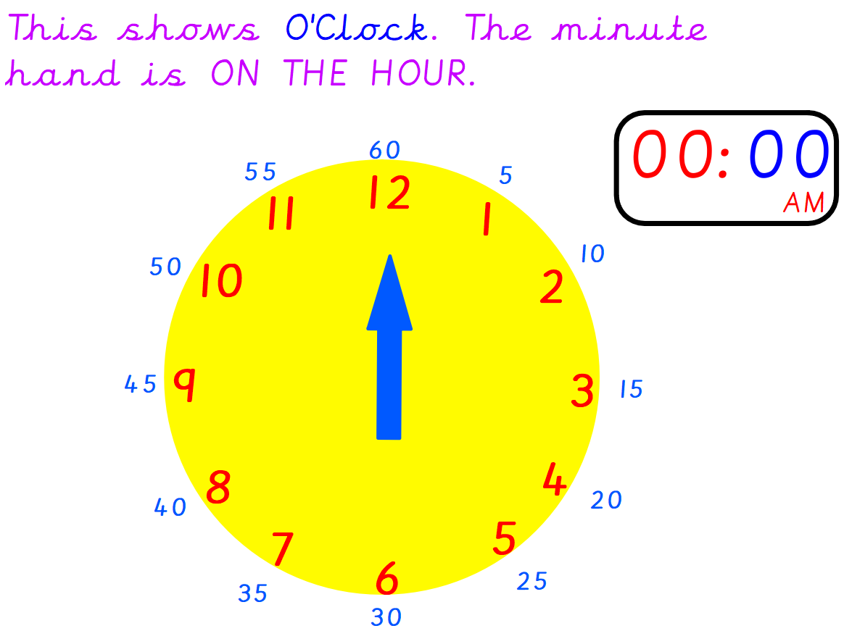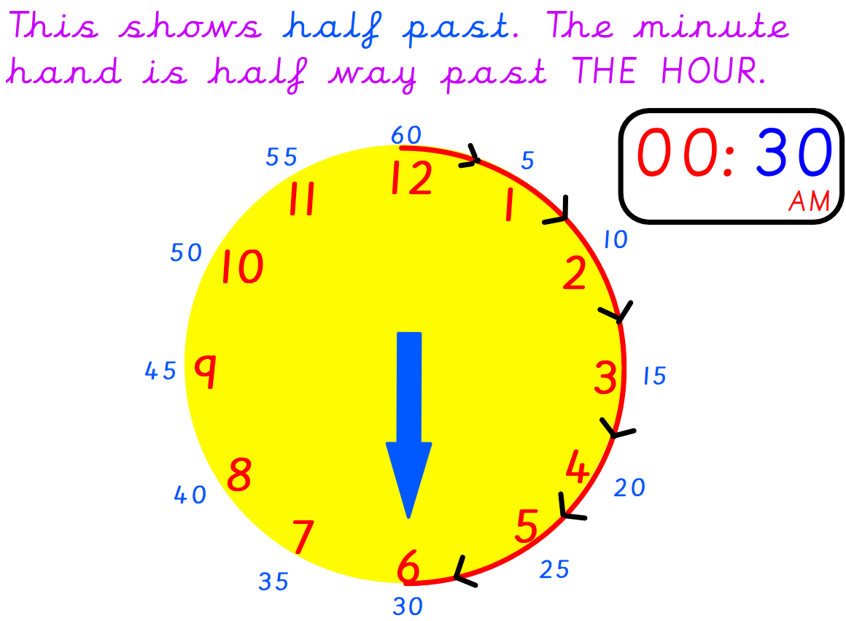
Can your child tell the time on these clocks below?
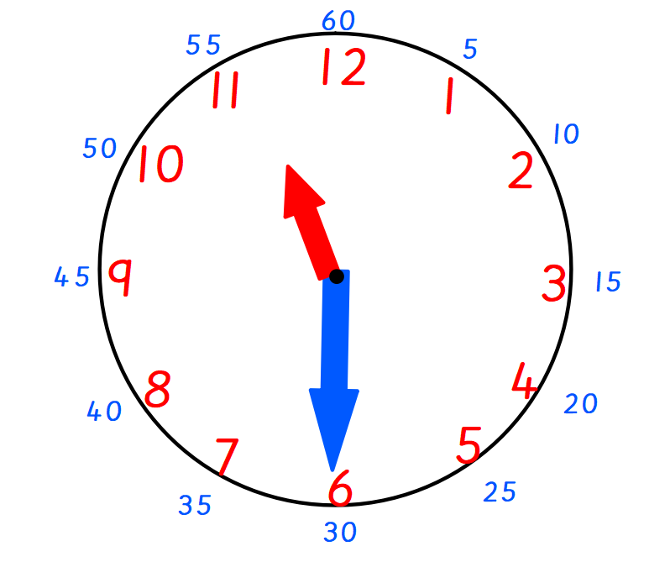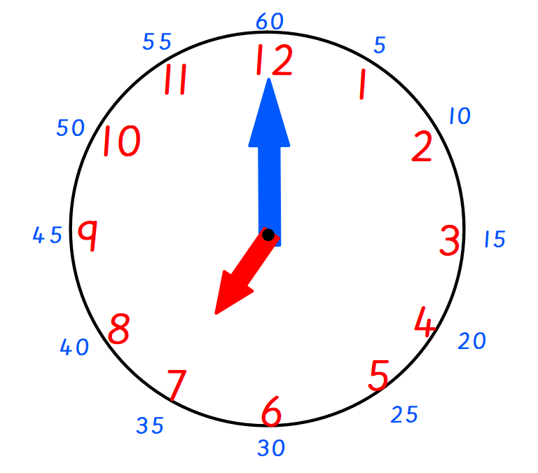

The children’s topic this half term is ‘Rio Da Vida. As part of topic lessons, children have continued their Geography learning. Children were given a coloured map of the world and their own blank map of the continents containing a key. They had to locate each continent on the world map and colour it in the same colour, as well as on their key. The next step was to label the continents to further check the children could identify and locate them. We then learnt about directions North, East, South and West. We discussed this in relation to the continents whilst looking at a world map. For example, Asia is to the East of Europe.

Can your child name the seven continents?
Can your child tell you which continent Brazil is in?

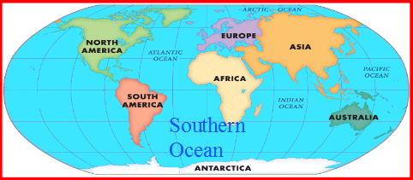

This week is also safety week! Children have completed a series of activities linked to keeping safe. They received a visit from a firefighter about fire safety, a police officer to talk about stranger danger and they had a visit from an A+E nurse. The children also visited Jackie, our lovely lollipop lady who taught us all about road safety and the essential steps to take when crossing a road. The children then completed lots of activities related to this including a ‘’stop drop roll’ poster for fire safety, identifying trusted adults in our neighbourhood, instructions for crossing the road and much more!

Can your child tell you the most interesting fact they’ve learnt from safety week this week?

Reminders:
Class 8 PE days are Monday and Tuesday.
Class 9 PE days are Monday and Wednesday.

Attendance for KS1:
Class 8 – 90.2%
Class 9 – 95.4%

Homework
Homework will mainly be handed out on a Wednesday. On the odd occasion it may be on a different day due to timetable changes. Please return homework on a Monday. Handing it on a Monday gives you the opportunity before the weekend to ask the teacher any questions so that you are clear of how to support your child if unsure. There is a tray in each class where the homework needs to be returned. Please ask the teacher where this tray is if unsure.

Spellings
Spellings are handed out each Thursday and your child will be tested on these spellings the following Thursday. Children will receive a list of spellings to practise each week. In addition to the spellings, children will be tested on a sentence containing the words. However, the sentence will not be sent home. This is to see if they can apply the spelling currently within their writing. Can you get your child to practise applying the words by creating their very own sentences?

Reading Diaries
Children in KS1 have all been provided with a Home Reading Diary. Please fill this in daily based on your child reading a couple of pages of a book or a whole book. Please return the Reading Diary to school each day and leave it in the designated classroom tray. There are books situated in the classroom for your child to take home daily. Reading is extremely important to your child’s development so we really encourage your child to read a book or pages of a book daily. If you are unsure of your child’s reading book colour then please ask your teacher.

Thank you
Miss Rawding & Miss Payne

