
Weekly Newsletter
W.B. 5.2.24

Please can we ask that any reading books taken home are returned to your child’s classroom book boxes after they’ve been used.

This week:

As part of English this week the children have continued their second cycle of story writing. The children wrote the problem of their story using the story language ‘Suddenly’, the resolution of their story which starts with ‘Fortunately’ and the end which starts with the story language ‘In the end’.

Can your child re-tell you the ‘resolution’ of their story?
Can your child tell you the story language we use for the ‘end’ of a story? (In the end)

As part of Maths this week children have continued learning about time. After learning how to tell the time on an analogue clock, we moved onto learning to tell the time on digital clocks too. The first two digits represent the hour of the day and the next two digits in a digital clock show the minutes that are past that hour.

Please look at the information below with your child.

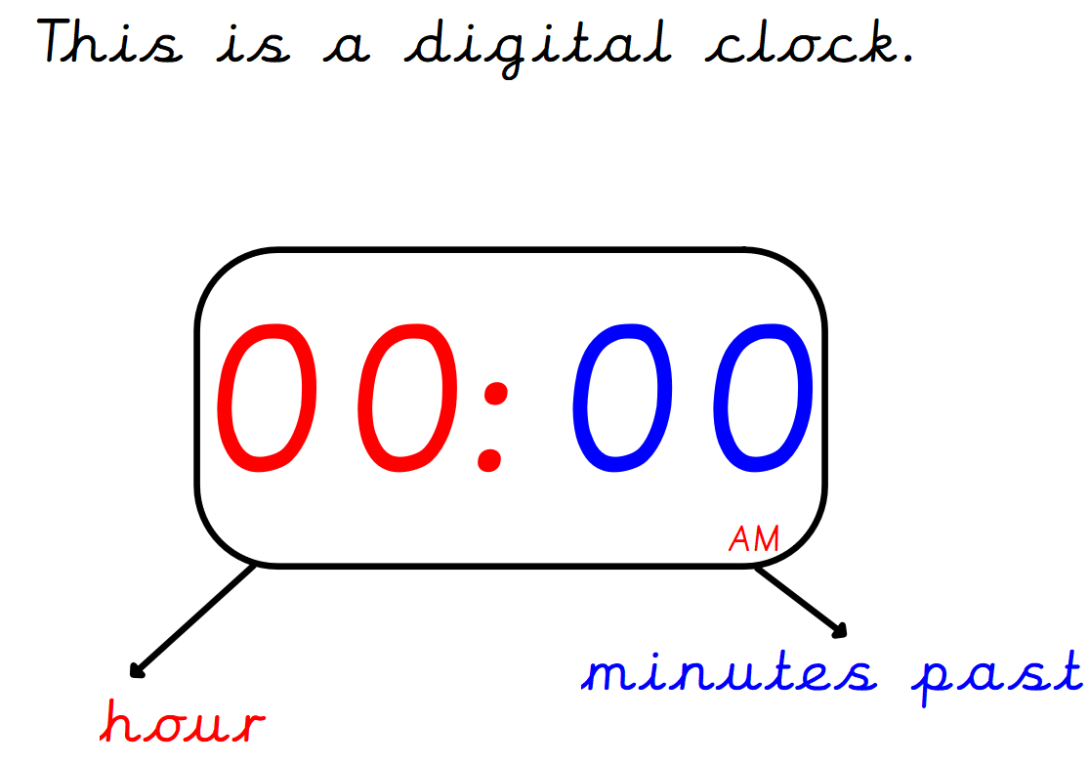

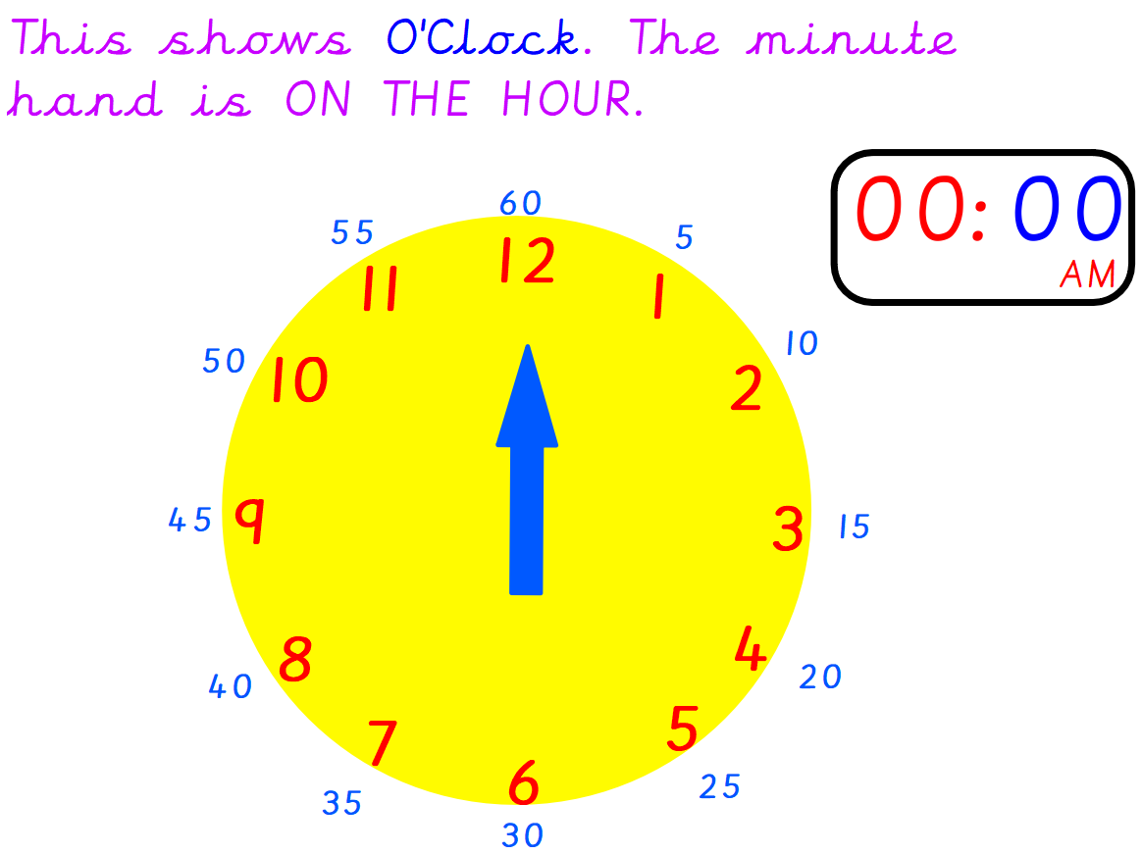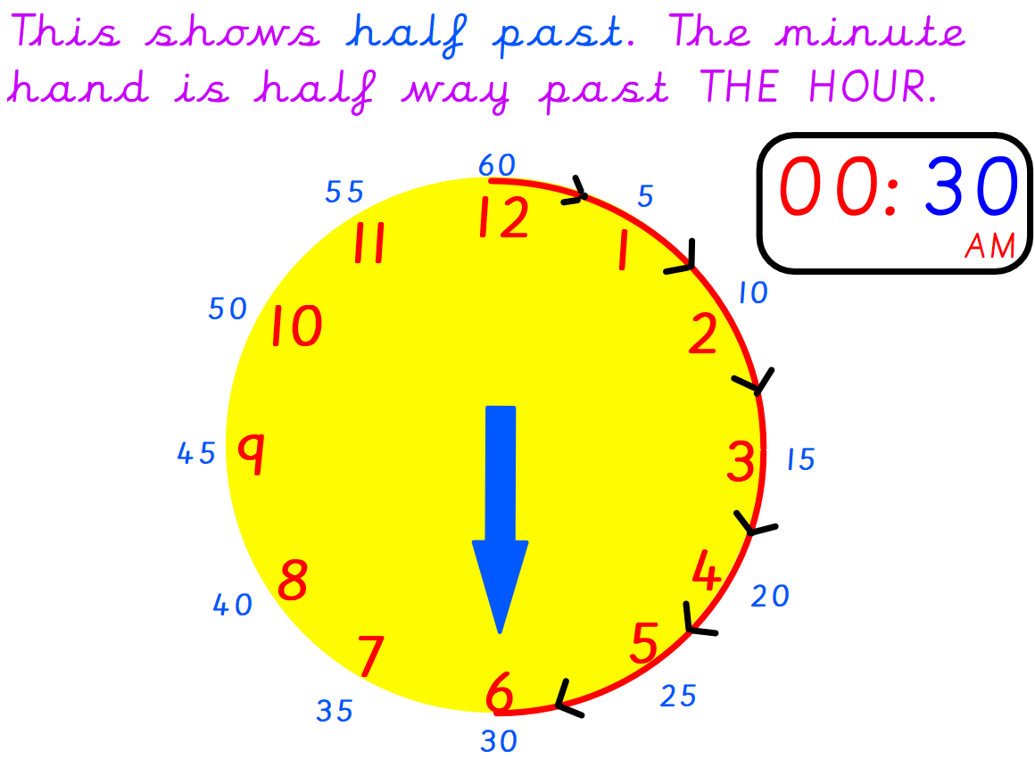
Can your child tell the time on these digital clocks below?

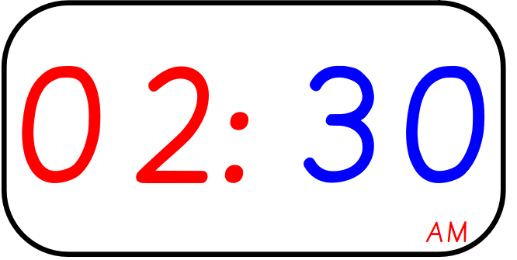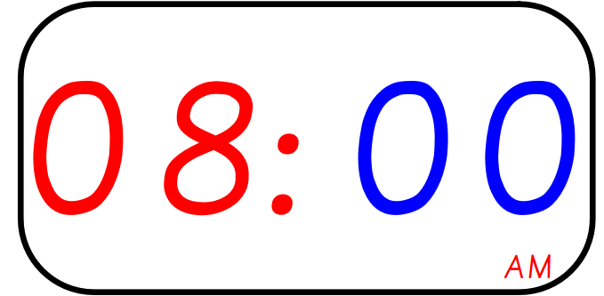

The children’s topic this half term is ‘Rio Da Vida. As part of topic lessons, children have continued their geography learning about the continents and countries within them. This week, the children have been learning about the United Kingdom (UK) and the four countries within it. They had to name and locate England, Scotland, Wales and Northern Ireland and colour them in the correct colour using a map of the UK. They then had to answer some questions about the four countries such as ‘which is the biggest country in the UK?’ and ‘which country do we live in?’. After that, we learnt about some key features of England including The River Thames, Scafell Pike, St Michael’s Mount and Sheffield. We had to locate these features on our own blank map of England and then name them on our own key. Finally, we compared two places in England; Fox Valley and St Michael’s Mount by looking at key similarities and differences including weather, population and location.
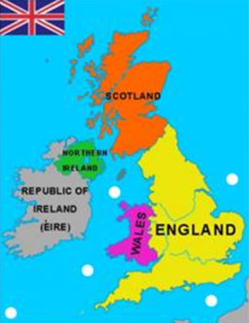

Can your child tell you which continent the UK is in?
Can your child tell you which country is to the north of England?

Reminders:
Class 8 PE days are Monday and Tuesday.
Class 9 PE days are Monday and Wednesday.

Attendance for KS1:
Class 8 – 92.3%
Class 9 – 92.2%

Homework
Homework will mainly be handed out on a Wednesday. On the odd occasion it may be on a different day due to timetable changes. Please return homework on a Monday. Handing it on a Monday gives you the opportunity before the weekend to ask the teacher any questions so that you are clear of how to support your child if unsure. There is a tray in each class where the homework needs to be returned. Please ask the teacher where this tray is if unsure.

Spellings
Spellings are handed out each Thursday and your child will be tested on these spellings the following Thursday. Children will receive a list of spellings to practise each week. In addition to the spellings, children will be tested on a sentence containing the words. However, the sentence will not be sent home. This is to see if they can apply the spelling currently within their writing. Can you get your child to practise applying the words by creating their very own sentences?

Reading Diaries
Children in KS1 have all been provided with a Home Reading Diary. Please fill this in daily based on your child reading a couple of pages of a book or a whole book. Please return the Reading Diary to school each day and leave it in the designated classroom tray. There are books situated in the classroom for your child to take home daily. Reading is extremely important to your child’s development so we really encourage your child to read a book or pages of a book daily. If you are unsure of your child’s reading book colour then please ask your teacher.

Thank you
Miss Rawding & Miss Payne

