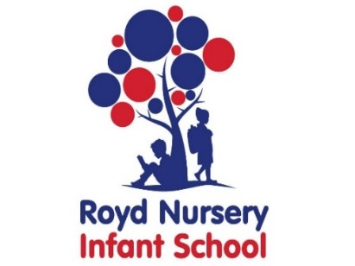

Royd Nursery Infant School

Carr Road, Deepcar

Sheffield, S36 2PR

Tel 0114 288 2594

Email [enquiries@royd.sheffield.sch.uk](mailto:enquiries@royd.sheffield.sch.uk)

[www.roydnurseryinfants.co.uk](http://www.roydnurseryinfants.co.uk)

Headteacher: Louise Jones

6 March 2024

Dear Parents / Carers,

**Monday 25 March 2024 until Thursday 28 March 2024 – Easter Activities**

As part of our Easter celebrations this year our 2 year and Nursery provision will be carrying out the following traditions; best decorated egg and Easter bonnet/hat competitions with prizes being awarded.

All eggs need to be hard boiled and labelled with your child’s full name. The Easter hats/bonnets and best decorated eggs need to be brought into school, already made/decorated. The best decorated egg and Easter Bonnet/Hat will be chosen during school time.

Funds raised on the day will be donated to the School Fund. With this in mind we are asking parent/carers to donate a minimum of £1 to a maximum of £5 via Parentpay. Thank you.

Have fun decorating the eggs and making the bonnets/hats. We can’t wait to see the different creations you come up with.

Yours sincerely,

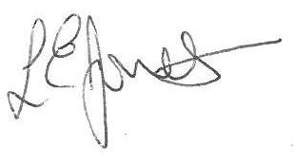

Louise Jones Sean Sly

Executive Head Acting Deputy Head

