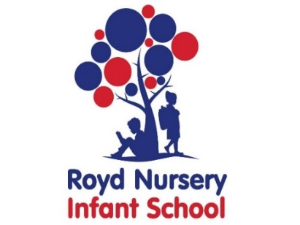

Royd Nursery Infant School

Carr Road, Deepcar

Sheffield, S36 2PR

Tel 0114 288 2594

Email [enquiries@royd.sheffield.sch.uk](mailto:enquiries@royd.sheffield.sch.uk)

[www.roydnurseryinfants.co.uk](http://www.roydnurseryinfants.co.uk)

Headteacher: Louise Jones

6 March 2024

Dear Parents / Carers,

**Wednesday 27 March 2024 – Easter Activities**

Both schools will be completing some fun Easter activities on Wednesday 27 March 2024.

As part of our Easter celebrations this year we will be carrying out some traditions from both schools. All children from FS2 to Y6 can enter ‘Best Decorated Egg’, ‘Egg Rolling’ and ‘Easter Bonnet/Hat’ competitions. There will be prizes awarded. All eggs need to be hard boiled and labelled with your child’s name. Pupils will need one decorated egg and one hard boiled (two per pupil). The Easter hats/bonnets and eggs need to be brought into school, already made/decorated, on the day.

The Best Decorated Egg and Easter Bonnet/Hat will be chosen during school time.

The eggs that have been brought in for the egg rolling will be rolled down the drive of Deepcar St John’s CE Junior aiming at a Humpty Dumpty figure. Photographs will be posted on social media.

Funds raised on the day will be donated to the School Fund. With this in mind we are asking parent/carers to donate a minimum of £1 to a maximum of £5 via Parentpay to enter all the activities .

Have fun decorating the eggs and making the bonnets/hats. We can’t wait to see the different creations you come up with.

Yours sincerely,

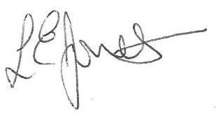

Louise Jones Sean Sly

Executive Head Acting Deputy Head

