

Royd Nursery Infant School

Carr Road, Deepcar

Sheffield, S36 2PR

Tel 0114 288 2594

Email [enquiries@royd.sheffield.sch.uk](mailto:enquiries@royd.sheffield.sch.uk)

[www.roydnurseryinfants.co.uk](http://www.roydnurseryinfants.co.uk)

Headteacher: Louise Jones

8 March 2024

Dear Parents/Carers,

On Thursday 21 March 2024 the LINKs School Sports Partnership are running an Inclusive Games Festival for Year 2 children.

The event will be at Stocksbridge High School at 3.30 pm and finishes at 4.30 pm. It will include sports such as Kurling, Boccia, seated volleyball and more. Pupils need to wear a PE kit, suitable footwear and take a water bottle.

Please be aware that you will need to stay with your child and that School is not providing transport therefore, parents/carers will need to arrange travel for any child that wishes to attend.

If your child would like to attend, email Mrs Stuart on [pstuart@royd.sheffield.sch.uk](mailto:pstuart@royd.sheffield.sch.uk) or ring the school office. Thank you.

Yours sincerely,

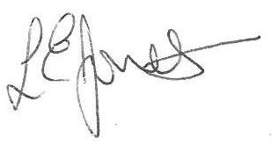

Louise Jones Sean Sly

Executive Head Acting Deputy Head





