22nd March 2024

The Jungle Book- Visiting Theatre Company

Dear Parent/Carers,

We have organised for the children at both schools (Reception to Y6) to watch ‘The Jungle Book’ on Friday 19th April 2024.

This will be a joint event for children at both Royd Nursery Infant School & Deepcar St John’s CE Junior School. There will be no cost to parents/carers for this event, however consent must be provided for your child to watch.

As notified in the February newsletter, children from Royd Nursery Infant School will be going around to Deepcar St Johns to watch the pantomime.

If you would like your child to attend please consent by completing the electronic form below.

https://forms.microsoft.com/e/Xnh8DgJDbx

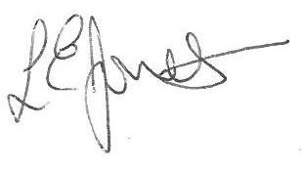
Yours sincerely,

Louise Jones
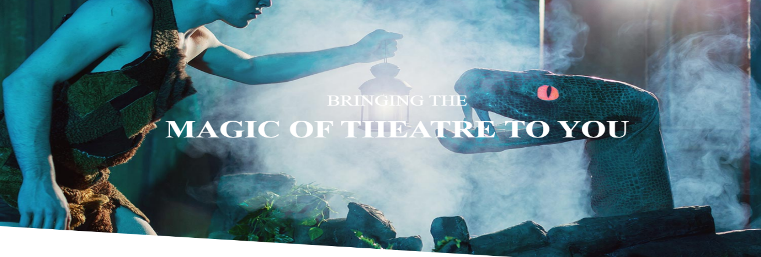
Executive Head

