
Weekly Newsletter
W.B. 4.3.24

Please can we ask that any reading books taken home are returned to your child’s classroom book boxes after they’ve been used.

This week:

In Maths the children in Year 2 have started their new unit around addition and subtraction. Children have learned how to use a number line to help them work out their calculations and also to make sure when adding, they re-order their calculation to make sure the biggest number is at the start of the calculation. We have encouraged the children to use their place value knowledge when completing their calculations on a number line, looking carefully at the tens and ones in a number e.g:
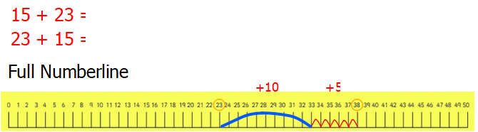

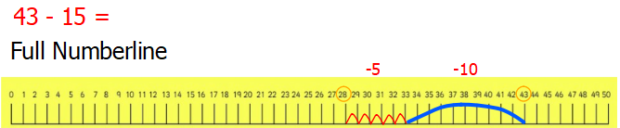

Can your child identify the number of tens and ones in a number?
Can they use a number line to help them complete addition and subtraction calculations?
Can they re-order their calculation to make the biggest number go first in the calculation?

Our topic this half-term is ‘Bright Lights Big City. As part of topic lessons, the children have started their Geography learning. We started off by learning that a human feature is a feature that is man-made such as a house and a physical feature is something made naturally by the earth such as a cliff. For their task, the children looked at a map of the school playground and used this to find objects in the playground and decide if they were human or physical features. The children loved this map work and really enjoyed having to follow the map to find things in the playground. At the end of the week, we let the children design their own map of a playground, creating their own key and objects.

Can your child give you an example of a physical feature?
Can your child give you an example of a human feature?

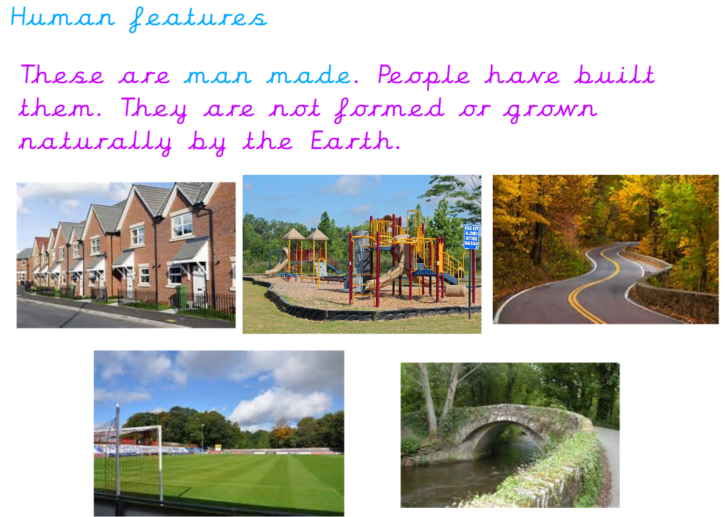

Reminders:
Class 7 PE days are Monday and Tuesday.
Class 8 PE days are Monday and Tuesday.

Attendance for KS1:
Class 7 – 0%
Class 8 – 0%

Homework
Homework will mainly be handed out on a Wednesday. On the odd occasion it may be on a different day due to timetable changes. Please return homework on a Monday. Handing it on a Monday gives you the opportunity before the weekend to ask the teacher any questions so that you are clear of how to support your child if unsure. There is a tray in each class where the homework needs to be returned. Please ask the teacher where this tray is if unsure.

Spellings
Spellings are handed out each Thursday and your child will be tested on these spellings the following Thursday. Children will receive a list of spellings to practise each week. In addition to the spellings, children will be tested on a sentence containing the words. However, the sentence will not be sent home. This is to see if they can apply the spelling currently within their writing. Can you get your child to practise applying the words by creating their very own sentences?

Reading Diaries
Children in KS1 have all been provided with a Home Reading Diary. Please fill this in daily based on your child reading a couple of pages of a book or a whole book. Please return the Reading Diary to school each day and leave it in the designated classroom tray. There are books situated in the classroom for your child to take home daily. Reading is extremely important to your child’s development so we really encourage your child to read a book or pages of a book daily. If you are unsure of your child’s reading book colour then please ask your teacher.

Thank you
Miss Bamford & Miss Payne

