
Weekly Newsletter
W.B. 11.3.24

Please can we ask that any reading books taken home are returned to your child’s classroom book boxes after they’ve been used.

This week:

As part of English this week the children have started their new genre of writing: a persuasive speech. We have acted out a persuasive speech, creating our own actions to help us remember some key words! We have also analysed a WAGOLL (What a Good One Looks Like) and we have identified all the features needed in a persuasive speech. These include: introduction, explain each argument, paragraphs, conclusion, present tense, conjunctions and punctuation. The persuasive speech we are focusing on is based around convincing Miss Jones to keep the playtime equipment by stating the benefits it brings us.

Can your child tell you some reasons why the playtime equipment helps us?

In Maths we have continued learning about number bonds. We looked at number bonds to 15, 16, 17, 18 and 19 this week. We used a range of resources to help us calculate these number bonds including Numicon, Dice, Part-Part Whole and shaker trays.

Can your child recall some number bonds for these numbers?

Our topic for this half term is ‘Bright Lights Big City’. As part of topic lessons, the children have started their Science learning all about weather. We began by discussing the four seasons; Spring, Summer, Autumn and Winter and the types of weather we would usually see within these seasons. For example, snow in Winter and sun in Summer. We then looked at the effects of weather types and decided if these were positive effects or negative effects. For example, rain provides water which helps plants to grow, however, too much rain can cause flooding and this can cause a lot of damage.

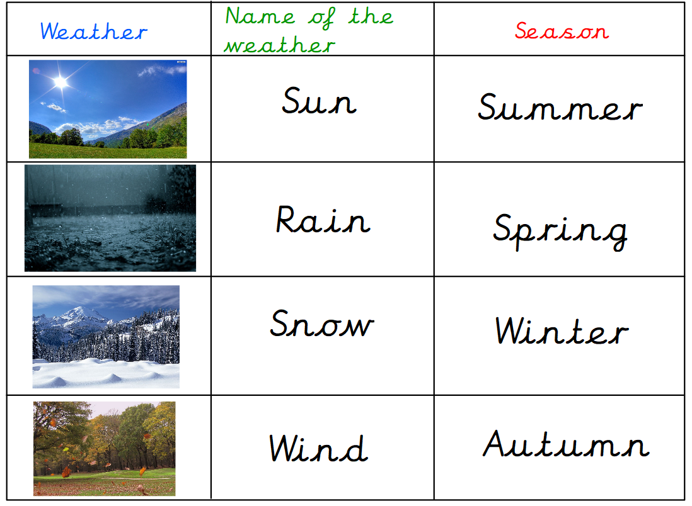
Can your child tell you a positive and negative effect of each weather type?

We then looked at day length to find out which months/seasons have the most sunlight and which have the least.

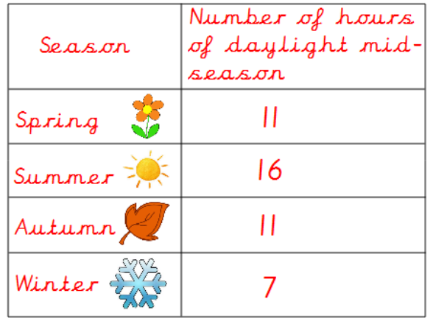

Which season is the hottest/coldest?
Which season has the longest amount of daylight mid-season?

Reminders:
Class 8 PE days are Monday and Tuesday.
Class 9 PE days are Monday and Wednesday.

Attendance for KS1:
Class 8 – 94.6%
Class 9 – 93%

Homework
Homework will mainly be handed out on a Wednesday. On the odd occasion it may be on a different day due to timetable changes. Please return homework on a Monday. Handing it on a Monday gives you the opportunity before the weekend to ask the teacher any questions so that you are clear of how to support your child if unsure. There is a tray in each class where the homework needs to be returned. Please ask the teacher where this tray is if unsure.

Spellings
Spellings are handed out each Thursday and your child will be tested on these spellings the following Thursday. Children will receive a list of spellings to practise each week. In addition to the spellings, children will be tested on a sentence containing the words. However, the sentence will not be sent home. This is to see if they can apply the spelling currently within their writing. Can you get your child to practise applying the words by creating their very own sentences?

Reading Diaries
Children in KS1 have all been provided with a Home Reading Diary. Please fill this in daily based on your child reading a couple of pages of a book or a whole book. Please return the Reading Diary to school each day and leave it in the designated classroom tray. There are books situated in the classroom for your child to take home daily. Reading is extremely important to your child’s development so we really encourage your child to read a book or pages of a book daily. If you are unsure of your child’s reading book colour then please ask your teacher.

Thank you
Miss Rawding & Miss Payne

