
Weekly Newsletter
W.B. 18.3.24

Please can we ask that any reading books taken home are returned to your child’s classroom book boxes after they’ve been used.

This week:

This week in English the children have continued their new genre of writing: writing a persuasive speech. We have talked about important benefits of Stocksbridge Leisure Centre and how we would feel if it were to be closed. We then used these ideas to form a plan for each section of our persuasive speech to help us to write our letter to the government. We first focused on writing the introduction of our letter, remembering important features such as capital letters for names and exclamation marks to help express how we are feeling. We then went on to writing the main body of the speech, thinking about the benefits of the leisure centre, why they are important to us and why they should stay.

Can your child tell you the features a persuasive speech has?
Can they use some persuasive language and convince you that Stocksbridge Leisure Centre should remain open?

In Maths the children have continued their unit around addition and subtraction. Children this week have learned how to find the missing number in the middle of a subtraction calculation and at the start. The children have been exposed to the following rhymes to help them complete the missing numbers in the calculation:
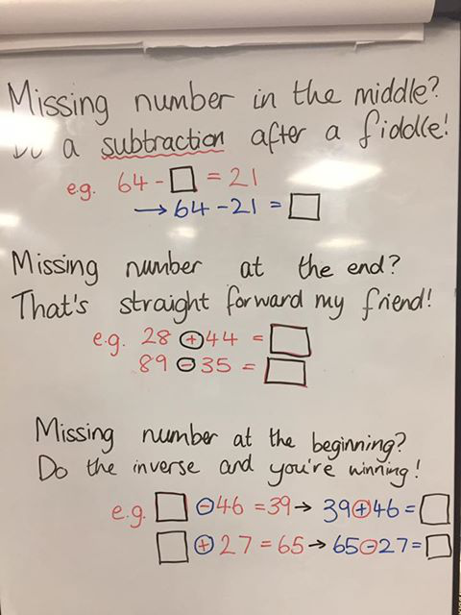

Can your child complete the following calculations using the rhymes to help them?

72 - __ = 34
__ - 16 = 57
98 - __ = 65
__ - 22 = 41

Our new topic this half term is ‘Street Detectives’. As part of topic lessons, the children started their science learning around weather. The children have been learning all about the Earth and how it rotates around the sun to give us the seasons. The children loved learning about this and enjoyed the video clips that supported their learning on this. We also looked at different types of extreme weather such as a tornado, flash flood and drought.

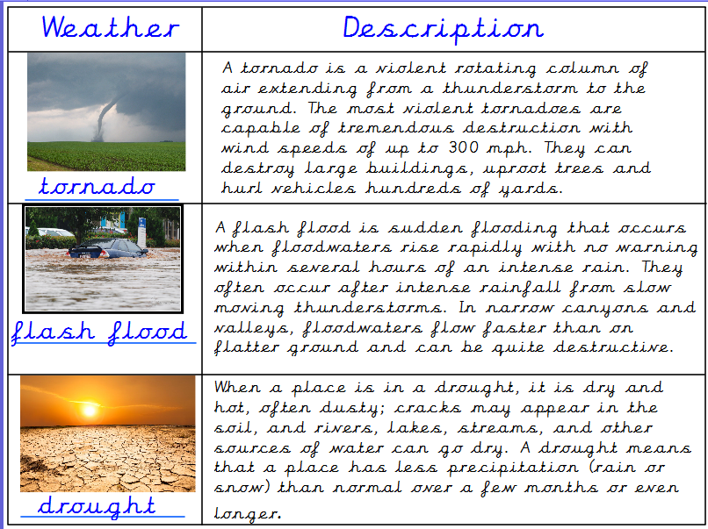

Can your child explain why we get seasons?
Can your child describe what the weather is (usually) like in each of the four seasons?

Reminders:
Class 7 PE days are Monday and Tuesday.
Class 8 PE days are Monday and Tuesday.

Attendance for KS1:
Class 7 – 0%
Class 8 – 0%

Homework
Homework will mainly be handed out on a Wednesday. On the odd occasion it may be on a different day due to timetable changes. Please return homework on a Monday. Handing it on a Monday gives you the opportunity before the weekend to ask the teacher any questions so that you are clear of how to support your child if unsure. There is a tray in each class where the homework needs to be returned. Please ask the teacher where this tray is if unsure.

Spellings
Spellings are handed out each Thursday and your child will be tested on these spellings the following Thursday. Children will receive a list of spellings to practise each week. In addition to the spellings, children will be tested on a sentence containing the words. However, the sentence will not be sent home. This is to see if they can apply the spelling currently within their writing. Can you get your child to practise applying the words by creating their very own sentences?

Reading Diaries
Children in KS1 have all been provided with a Home Reading Diary. Please fill this in daily based on your child reading a couple of pages of a book or a whole book. Please return the Reading Diary to school each day and leave it in the designated classroom tray. There are books situated in the classroom for your child to take home daily. Reading is extremely important to your child’s development so we really encourage your child to read a book or pages of a book daily. If you are unsure of your child’s reading book colour then please ask your teacher.

Thank you
Miss Bamford & Miss Payne

