2 Year Provision Newsletter
– w/c 11/03/24
Last week
Last week in provision we continued doing activities around our theme for this term,
“Are Eggs Alive?”

We also had activities around our World Book Week book, “The three Little Pigs”.
The children enjoyed dressing up as characters from different books. The children enjoyed acting out the story of the three little and built houses made from straw, sticks and bricks!
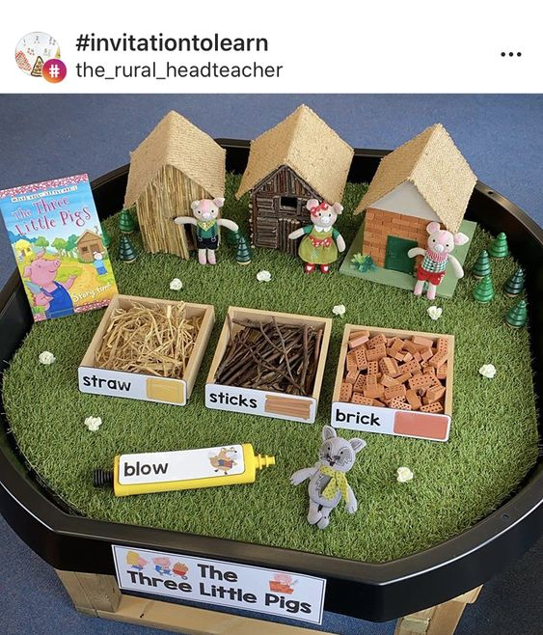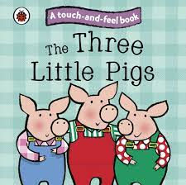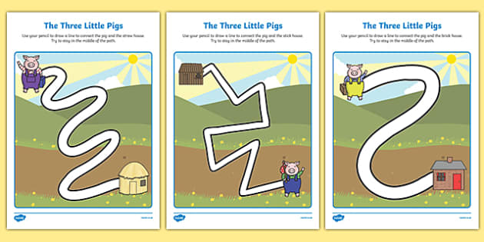

We also said goodbye to our chicks who have now been placed in new homes. It was so lovely having them in provision. Some of the children were lucky enough to see some of them hatch!

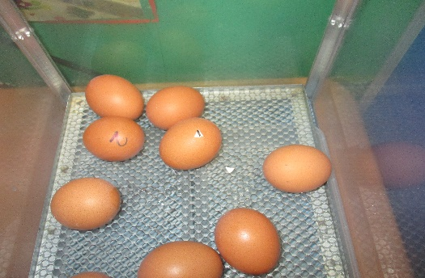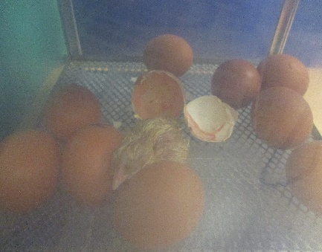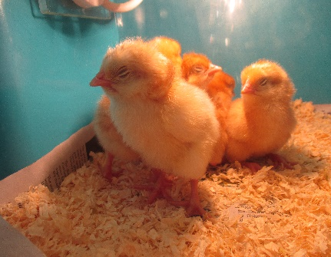

This week  We have the story teller coming into school on Wednesday 13th March. In provision this week we will have a fruit and veg shop in our role play area and we will be doing some planting with the children. | Book of the week  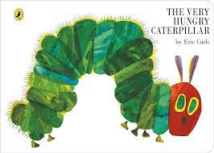  This story is linked to our theme we are running this term. Maybe if you have this story at home you could look though the story together at bedtime.
Dates for your Diary
Story Teller in school – Wednesday 13th March 2024
Red Nose day – Friday 15th March – Wear something Red
Parents Evening – Thursday 21st March & Wednesday 27th March 2024
Last Day of term - Thursday 28th^{t} March 2024

Spare Clothes
We are running very low on spare clothes, especially boys’ clothes. If you have any spares at home your child no longer fits in, or wears and your happy to donate them please bring them to the 2 year provision.
Thank you!

Reminder
A gentle reminder about only providing water in water bottles. Thank you.

Please ensure your child brings a warm coat, hat and gloves. We will be playing out in all weathers so if you would like to provide them with some wellingtons in a labelled carrier bags as we have some large puddles which develop when it rains heavy and children love to jump in muddy puddles!
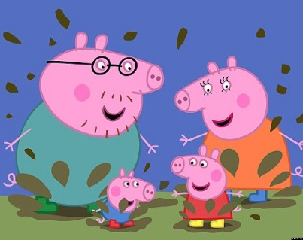
This Photo by Unknown Author is licensed under CC BY-NC-ND

Please remember to ensure all your child’s clothing and water bottles are labelled and if you could provide spare clothes in their bag as we are very low on spare clothes.
Thank you!

