2 Year Provision Newsletter
– w/c 26/02/24
Last week
Welcome back, we hope you had a lovely half term!

Last week in provision we began doing activities around our theme for this term, Are Eggs Alive? The activities included a sensory farm, matching number eggs and pom pom printing on eggs. The children have really enjoyed exploring the sensory farm!
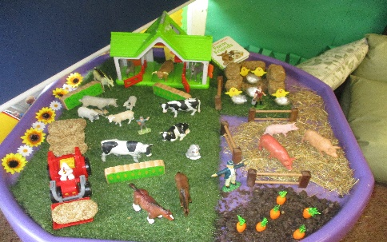

This week  We will be having visitors coming to stay with us for a couple of weeks!  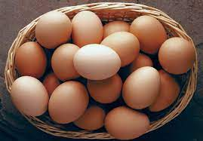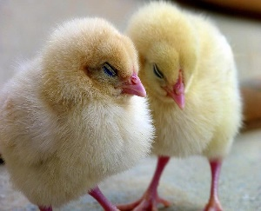  The eggs are arriving in school today and hopefully over the next two weeks the chicks will hatch! This is an amazing opportunity for the children to learn where chicks come from and how to look after and care for a living animals. | Book of the week  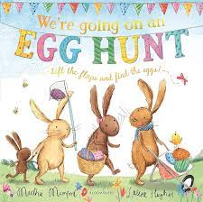  This story is linked to our theme we are running this term. Maybe if you have this story at home you could look though the story together at bedtime.
Dates for your Diary
World book Week – w/c 4th March – Come dressed in pyjamas or as a character from a book.
Story Teller in school – Wednesday 13th March 2024
Red Nose day – Friday 15th March – Wear something Red
Parents Evening – Thursday 21st March & Wednesday 27th March 2024
Last Day of term - Thursday 28th^{t} March 2024

Spare Clothes
We are running very low on spare clothes, especially boys’ clothes. If you have any spares at home your child no longer fits in, or wears and your happy to donate them please bring them to the 2 year provision.
Thank you!

Reminder
A gentle reminder about only providing water in water bottles. Thank you.

Please ensure your child brings a warm coat, hat and gloves. We will be playing out in all weathers so if you would like to provide them with some wellingtons in a labelled carrier bags as we have some large puddles which develop when it rains heavy and children love to jump in muddy puddles!
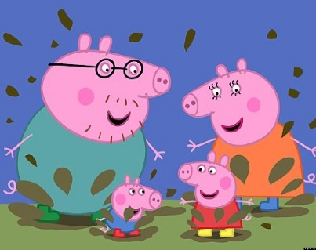
This Photo by Unknown Author is licensed under CC BY-NC-ND

Please remember to ensure all your child’s clothing and water bottles are labelled and if you could provide spare clothes in their bag as we are very low on spare clothes.
Thank you!

