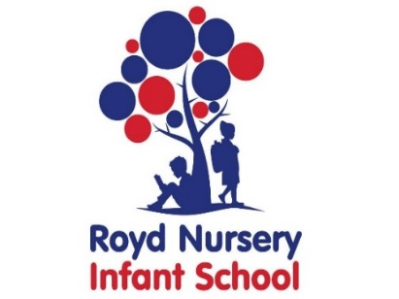

Royd Nursery Infant School

Carr Road, Deepcar

Sheffield, S36 2PR

Tel 0114 288 2594

Email [enquiries@royd.sheffield.sch.uk](mailto:enquiries@royd.sheffield.sch.uk)

[www.roydnurseryinfants.co.uk](http://www.roydnurseryinfants.co.uk)

Headteacher: Louise Jones

29 April 2024

Dear Parents/Carers,

Valley Music Festival are hosting their annual ‘Kids Make Music’ concert and Royd’s school choir have been invited to take part. The event will take place at Stocksbridge Venue on **Wednesday 12th June 2024.**

We would love the children who are part of our choir to take part and represent the talents of our school. Parents/Carers will be expected to arrive with their children at **5.30pm** so that children can be on stage for 6pm.

Ticket prices are **£3 for adults** and **free for children.** Parents/carers/family/friends of the children performing can purchase these tickets at the door, on the night of the concert.

We need to know exactly which of the Choir children are able to attend, therefore please could you complete and return the slip to school **by Friday 24th May.**

Please return the slip to School or email Mrs Stuart on [pstuart@royd.sheffield.sch.uk](mailto:pstuart@royd.sheffield.sch.uk).

Thank you.

Yours sincerely,

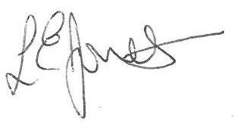

Louise Jones Sean Sly

Executive Head Acting Deputy Head

✂--------------------------------------------------------------------------------------------------------------

**‘Kids Make Music’ at Stocksbridge Venue 12 June 2024**

Child’s Name : Class :

Yes I/We will be able to bring my child to The ‘Kids Make Music’ Concert

No my child will not be attending

Signed …………………………………………………………….. Parent/Carer



