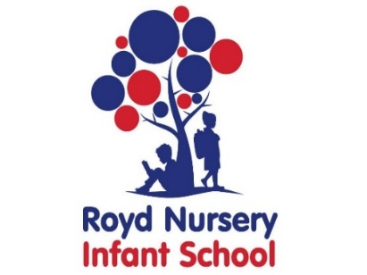

Royd Nursery Infant School

Carr Road, Deepcar

Sheffield, S36 2PR

Tel 0114 288 2594

Email [enquiries@royd.sheffield.sch.uk](mailto:enquiries@royd.sheffield.sch.uk)

[www.roydnurseryinfants.co.uk](http://www.roydnurseryinfants.co.uk)

Headteacher: Louise Jones

19 April 2024

Dear Parent/Carers

This term we have planned a visit to RSPB Old Moor at Dearne Valley for our children in Reception. Our topic is ‘why do spiders eat flies?’ where we are learning about different minibeasts. During the trip, the children will be able to hunt for minibeasts on land and also have a go at exploring minibeasts they find during pond-dipping. The contribution is £16.50 per child to cover transport cost and entrance fee.

The trip will be on Tuesday 21 May 2024.

It will be a full day visit and we will leave school at 9.15 am prompt and arrive back at school at approximately 3.15 pm. Children need to wear their school uniform with suitable clothing and footwear for walking around the wildlife site. Dependent on the weather, sun hats and lotion may also be needed. Children will also need to bring their water bottle.

School will provide a packed lunch and the choice of sandwich is cheese or ham. Please make your choice on Parentpay when providing consent. If you wish to send your child with your own packed lunch, again please indicate on Parentpay.

If you would like your child to attend, contributions and consent are by Parentpay. Please complete this by Friday 3 May 2024. If there are any issues please do not hesitate to contact Mr Sly. Thank you.

We would also appreciate parent/carer volunteers. Please let Miss Brook or Miss Brown know if you would like to come along on the trip.

Yours sincerely,

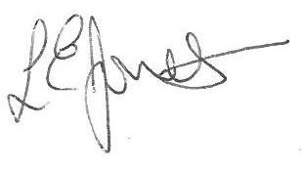

Louise Jones Sean Sly

Executive Head Acting Deputy Head



