
Weekly Newsletter
W.B. 22.4.24

Please can we ask that any reading books taken home are returned to your child’s classroom book boxes after they’ve been used.

This week:

This week in English the children have continued their next story writing focus. We have been looking at key spelling rules for adding a range of suffixes to root words. We started off with the suffix ‘s’ and ‘es’ which changes a root word to either plural or a third person verb. We have also looked at the suffix ‘ed’ which makes words past tense and the suffix ‘ing’ which can make words present tense.

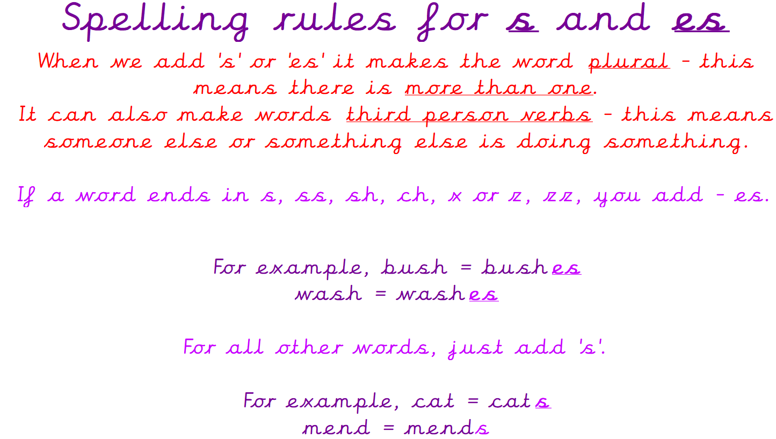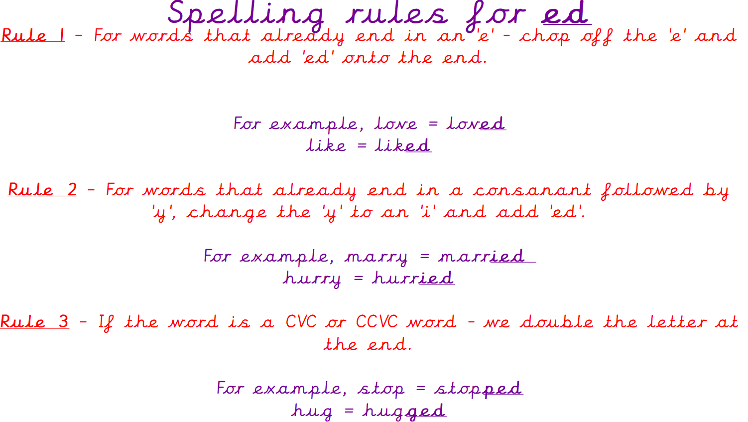
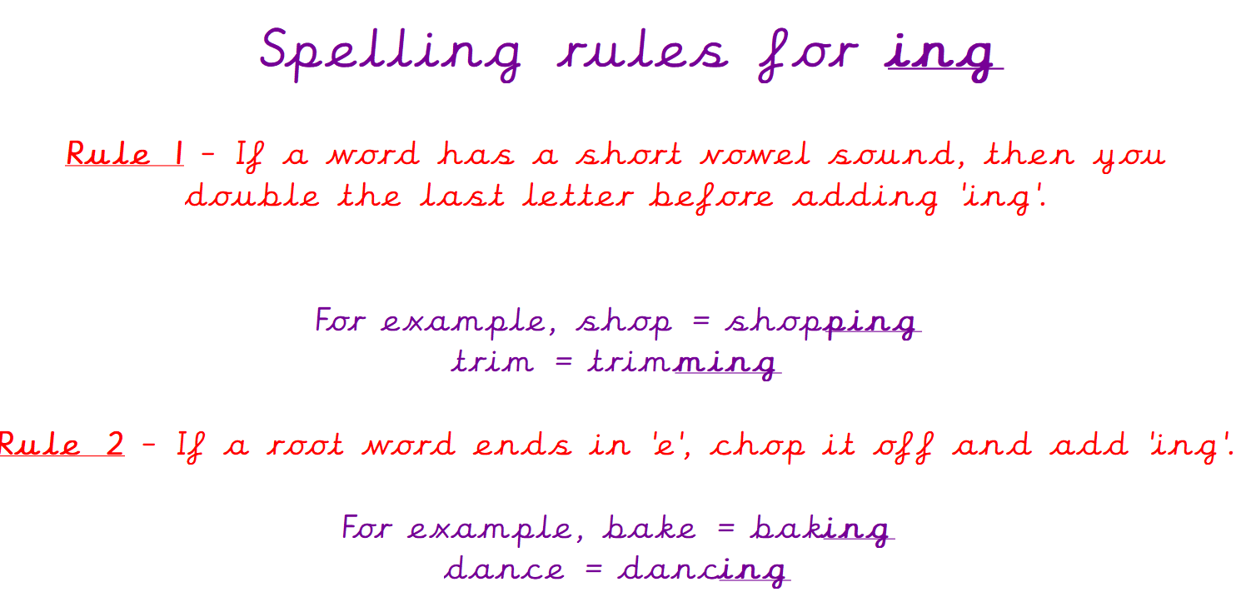

Can your child tell you the spelling rules for adding ‘s’ and ‘es’?
Can your child tell you what the suffixes ‘ed’ and ‘ing’ do to a root word?

As part of Maths this week children have continued their addition and subtraction unit. We have used our previous knowledge of number lines to complete addition calculations on partial number lines. First, we needed to remember to circle our first number on the number line, working out where it would be if the number was missing. Then, we counted on to find our answer. We used the same method to solve subtraction calculations, remembering to count backwards rather than forwards along the number line.

Can your child complete the following calculations using a number line?

5 + 7 =
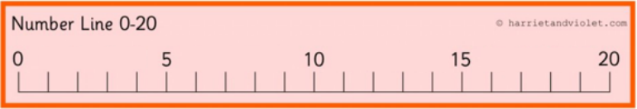
11 + 4 =

19 – 7 =
20 – 6 =

Our topic for this half term is ‘Enchanted Woodland’. As part of topic lessons, children have been completing some cross-curricular geography and computing lessons. We have been learning about weather and have researched about different weather types. After that, the children created posters in groups, each focusing on a different weather type. We then started learning about the four seasons in a year; Autumn, Winter, Spring and Summer.



Can your child name some weather types?
Can your child name the four seasons?

Reminders:
Class 8 PE days are Monday and Tuesday.
Class 9 PE days are Monday and Wednesday.

Attendance for KS1:
Class 8 – 97%
Class 9 – 97.4%

Homework
Homework will mainly be handed out on a Wednesday. On the odd occasion it may be on a different day due to timetable changes. Please return homework on a Monday. Handing it on a Monday gives you the opportunity before the weekend to ask the teacher any questions so that you are clear of how to support your child if unsure. There is a tray in each class where the homework needs to be returned. Please ask the teacher where this tray is if unsure.

Spellings
Spellings are handed out each Thursday and your child will be tested on these spellings the following Thursday. Children will receive a list of spellings to practise each week. In addition to the spellings, children will be tested on a sentence containing the words. However, the sentence will not be sent home. This is to see if they can apply the spelling currently within their writing. Can you get your child to practise applying the words by creating their very own sentences?

Reading Diaries
Children in KS1 have all been provided with a Home Reading Diary. Please fill this in daily based on your child reading a couple of pages of a book or a whole book. Please return the Reading Diary to school each day and leave it in the designated classroom tray. There are books situated in the classroom for your child to take home daily. Reading is extremely important to your child’s development so we really encourage your child to read a book or pages of a book daily. If you are unsure of your child’s reading book colour then please ask your teacher.

Thank you
Miss Rawding & Miss Payne

