2 Year Provision Newsletter
– w/c 25/03/24
Last week
Last week in provision we continued doing activities around our theme for this term,
“Are Eggs Alive?”
We have also been doing activities around the seasons and other spring animals, as well as our book of the week, The Very Hungry Caterpillar.
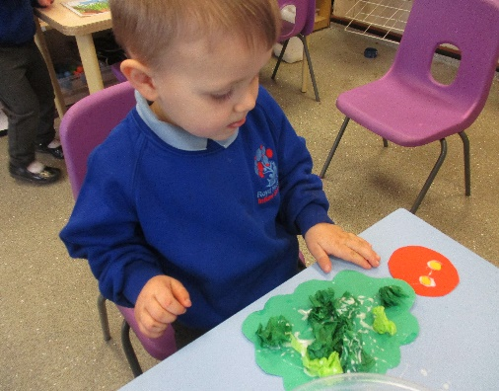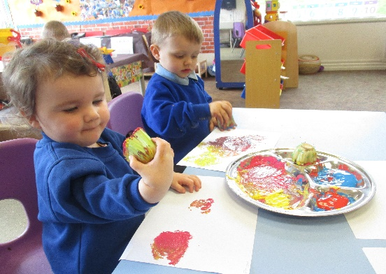

This week  This week we will be judging the Easter bonnets and decorated eggs brought in by the children. At the end of the week a winner will be announced and they will receive a prize!  This is our last week before we break up for the Easter holidays | Book of the week  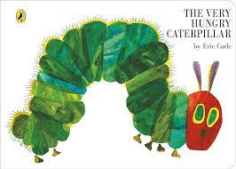  This story is linked to our theme we are running this term. Maybe if you have this story at home you could look though the story together at bedtime.
Dates for your Diary
Parents Evening –Wednesday 27th March 2024
Last Day of term - Thursday 28th^{t} March 2024

Spare Clothes
We are running very low on spare clothes, especially boys’ clothes. If you have any spares at home your child no longer fits in, or wears and your happy to donate them please bring them to the 2 year provision.
Thank you!

Reminder
A gentle reminder about only providing water in water bottles. Thank you.

Please ensure your child brings a warm coat, hat and gloves. We will be playing out in all weathers so if you would like to provide them with some wellingtons in a labelled carrier bags as we have some large puddles which develop when it rains heavy and children love to jump in muddy puddles!
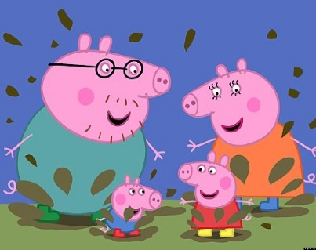
This Photo by Unknown Author is licensed under CC BY-NC-ND

Please remember to ensure all your child’s clothing and water bottles are labelled and if you could provide spare clothes in their bag as we are very low on spare clothes.
Thank you!

