2 Year Provision Newsletter
– w/c 22/04/24
Last week
Welcome Back!
It’s lovely to have you all back after the break, we hope you had a lovely Easter!

We would also like to say a massive welcome to all our new starters who have all settled really in well!

Last week in provision we have begun our new topic “Why do spiders eat flies?”
We have been doing activities around this including building a spider’s web, making spiders with our hands and looking outside for spiders and their webs!

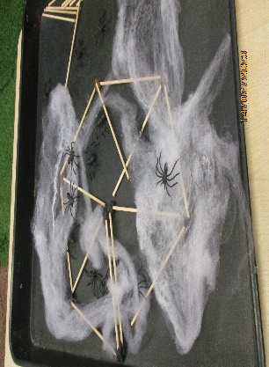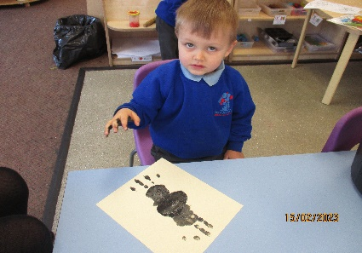

This week  We are continuing our theme around our topic. We are also looking at the seasons, talking about the weather. We are also looking at planting and growing. We have been growing some sunflowers in provision and will be giving each child one to plant and eventually take home so they can learn about how to care for a growing living thing. | Book of the week  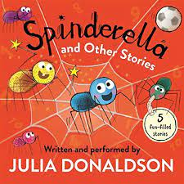  This story is linked to our theme we are running this term. Maybe if you have this story at home you could look though the story together at bedtime.
Dates for your Diary
Monday 6th May – Bank holiday Monday

Spare Clothes
We are running very low on spare clothes, especially boys’ clothes. If you have any spares at home your child no longer fits in, or wears and your happy to donate them please bring them to the 2 year provision.
Thank you!

Reminder
A gentle reminder about only providing water in water bottles. Thank you.

Please ensure your child brings a labelled coat, hat and gloves. We will be playing out in all weathers so if you would like to provide them with some wellingtons in a labelled carrier bags as we have some large puddles which develop when it rains heavy and children love to jump in muddy puddles!
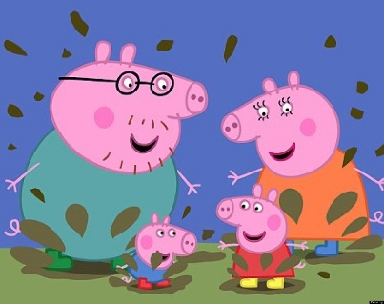
This Photo by Unknown Author is licensed under CC BY-NC-ND

Please remember to ensure all your child’s clothing and water bottles are labelled and if you could provide spare clothes in their bag as we are very low on spare clothes.
Thank you!

