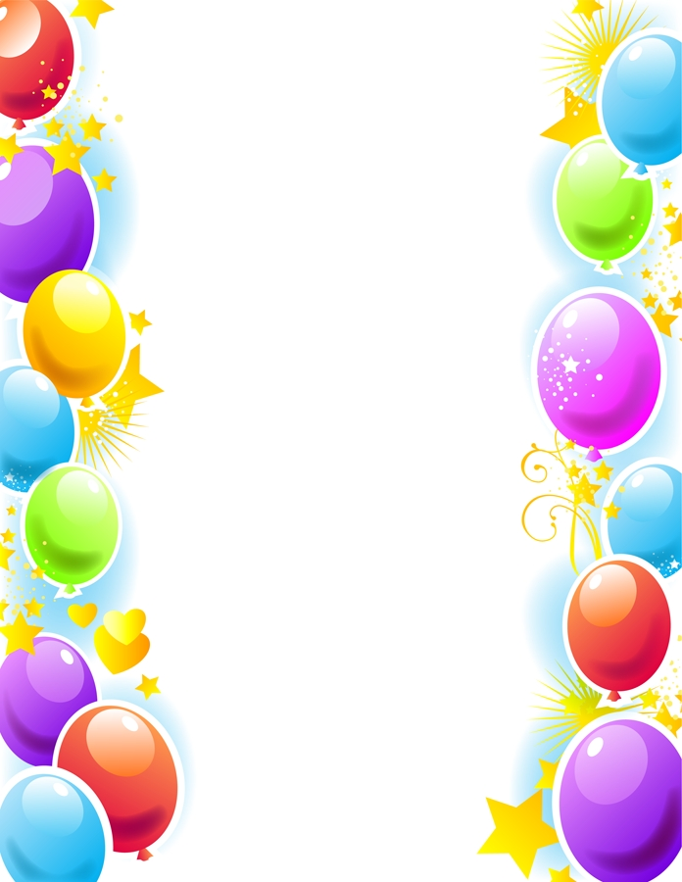
Weekly Newsletter
W.B. 4.11.24

This week:
As part of English this week the children have started their first poetry genre, focusing on the poem ‘I am a colossal house’. First the children had to create their own actions for different lines in the poem. After practising each line of the poem with their chosen actions, the children performed to each other. In the next lesson, we analysed key elements of a poem looking at the two stanzas (a group of lines) in our poem and the lines (there are eight lines in our poem, four in each stanza). Now that the children could perform and analyse our poem, they were ready to reorder it. The children were given the poem chopped up into pieces containing two lines at a time and had to work out the correct order to place them in. The children loved reading the poem aloud whilst they were doing this activity to remind them which line should come next.

Can your child tell you what a stanza is?

As part of Maths the children have been learning to count in 10’s forwards and backwards. The children know that when we count in
10’s the numbers end in a 0.

Can your child complete the counting sequences below by filling in the missing numbers? Remember to check whether the sequences are counting forwards or backwards first!

30, 40, ____, 60, 70, ___, ___
100, ___, 80, 70, ___, ____, 40

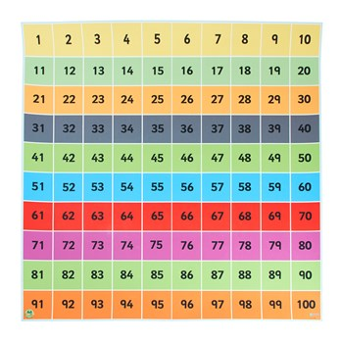
The children’s topic this half term is ‘Towers, Tunnels and Turrets’. In History, we have started learning about the different parts of a castle. In our first lesson, we listened to lots of information about castles for example the first castles built were ‘Motte and Bailey’ castles and then stone castles were built because wood was not strong enough. In our second history lesson, we labelled the different parts of a castle such as a moat around the castle or a portcullis to prevent enemies from entering or leaving the castle.

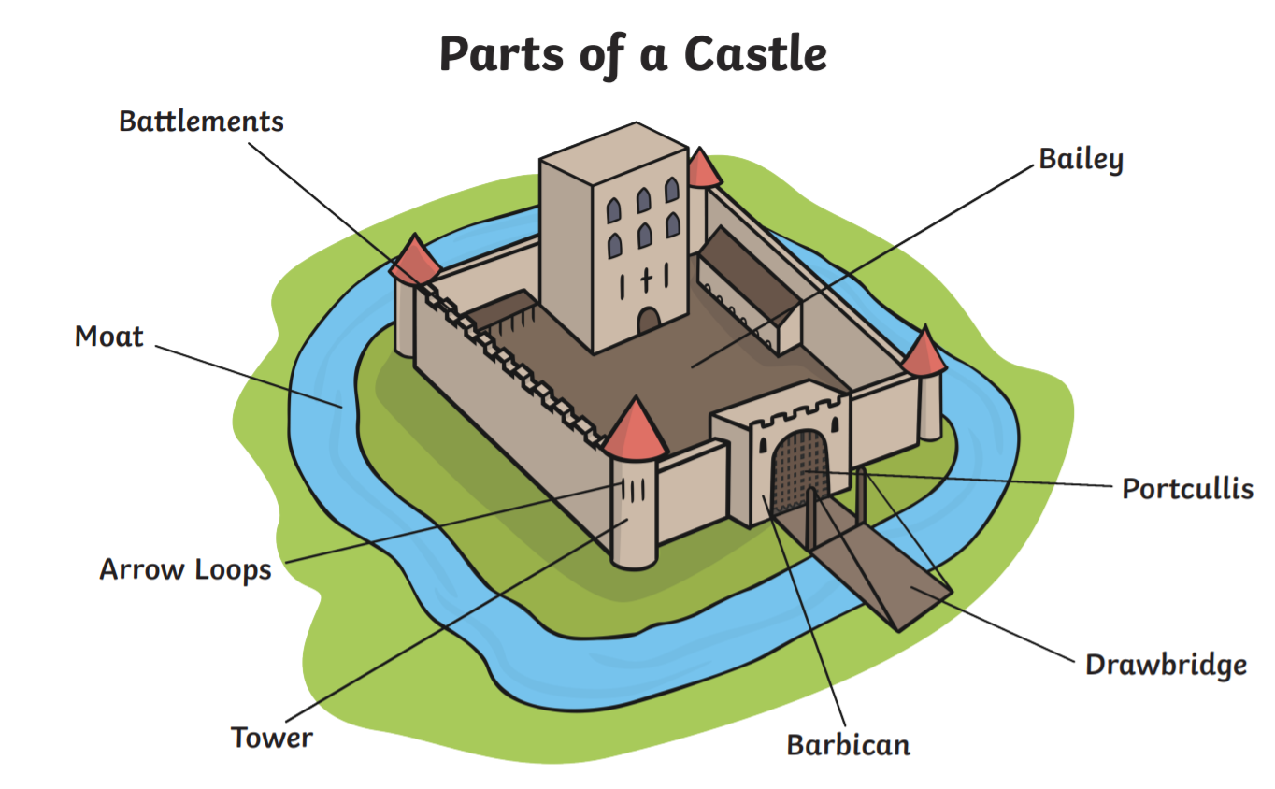

Can your child name the different parts of a castle?
Can your child tell you what a drawbridge is for?

Reminders:
All Year 1 children are doing PE on Thursdays. Children need a t-shirt, shorts (for indoor PE), long trousers (for outdoor PE), trainers and a jumper in their PE bags.
Year 2 children are swimming on Thursdays.

Attendance for KS1:
Class 7 – 94.6%
Class 8 – 98.3%
Class 9 – 97.5%

Homework
Homework will mainly be handed out on a Tuesday. On the odd occasion it may be on a different day due to timetable changes. Please return homework on a Monday. Handing it on a Monday gives you the opportunity before the weekend to ask the teacher any questions so that you are clear of how to support your child if unsure. There is a tray in each class where the homework needs to be returned. Please ask the teacher where this tray is if unsure.

Spellings
Spellings are handed out each Thursday and your child will be tested on these spellings the following Thursday. Children will receive a list of spellings to practise each week. In addition to the spellings, children will be tested on a sentence containing the words. However, the sentence will not be sent home. This is to see if they can apply the spelling currently within their writing. Can you get your child to practise applying the words by creating their very own sentences?

Reading Diaries
Children in KS1 have all been provided with a Home Reading Diary. Please fill this in daily based on your child reading a couple of pages of a book or a whole book. Please return the Reading Diary to school each day and leave it in their book bags. There are books situated in the classroom for your child to take home daily. Reading is extremely important to your child’s development so we really encourage your child to read a book or pages of a book daily. If you are unsure of your child’s reading book colour then please ask your teacher.

Online Safety
The Education for a Connected World framework is used by Royd Nursery Infant School to support in the delivery of online safety. It is a tool for anyone who works with children and young people. It enables the development of teaching and learning as well as guidance to support children and young people to live knowledgeably, responsibly and safely in a digital world.

It focuses specifically on eight different aspects of online education. Strand 6 focuses on “Health, well-being and lifestyle”

To view Strand 6 “Health, well-being and lifestyle” please click on the following link and scroll to page 31 and 32 (if you would like to know more about this strand and what is covered from ages 7 – 18 please scroll to pages 33 – 35):
https://assets.publishing.service.gov.uk/media/5efa05b4e90e075c5492d58c/UKCIS_Education_for_a_Connected_World_.pdf
Thank you
Miss Payne, Miss Howes & Miss Aldam

