
Weekly Newsletter
W.B. 21.10.24

This week:
As part of English the children have been planning and writing their story of Goldilocks and the Three Bears.
We have looked carefully at planning our story making sure that we have included all of our Y2 writing features such as, suffixes, ambitious words, expanded noun phrases and subordinating and coordinating conjunctions.
The children have worked so hard to make sure that they write in past tense and that their story is exciting.

Can your child retell the story of Goldilocks and the Three Bears?
Can they tell you their build up to the story?
Can they give you examples of expanded noun phrases?

In Maths this week the children have continued their work on number lines. The children have been working out missing numbers on a number line, trying to spot the multiples and if the pattern decreases (counting backwards) or increases (counting forwards). Sometimes the number lines have been counting off the multiple. This means it does not follow the regular pattern when counting in multiples. For example: The number line below increases by 3 each time and this is off the multiple:

Can your child work out missing numbers on a number line?
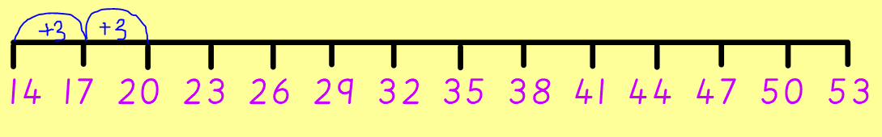
Can they work out if the numbers are increasing or decreasing?
Can they work out what multiples we are counting in?

The children’s topic this half term is ‘Memory Box’. The children have continued their science lessons by looking at food chains. The children have focused on key vocabulary to help them understand the food chain: Producer - the start of the food chain and they produce their own food. Consumer - feed on producers or other consumers to survive. They cannot make their own food. Predator - an animal that eats other animals. The children then really enjoyed creating their own food chains using pictures of different producers, consumers and predators.

Can your child tell you the meaning of each of these 3 words?
Can they explain what a food chain is?

Reminders:
All Year 1 children are doing PE on Thursdays. Children need a t-shirt, shorts (for indoor PE), long trousers (for outdoor PE), trainers and a jumper in their PE bags.
Year 2 children are swimming on Thursdays.

Attendance for KS1:
Class 7 – 94.6%
Class 8 – 98.3%
Class 9 – 97.5%

Homework
Homework will mainly be handed out on a Tuesday. On the odd occasion it may be on a different day due to timetable changes. Please return homework on a Monday. Handing it on a Monday gives you the opportunity before the weekend to ask the teacher any questions so that you are clear of how to support your child if unsure. There is a tray in each class where the homework needs to be returned. Please ask the teacher where this tray is if unsure.

Spellings
Spellings are handed out each Thursday and your child will be tested on these spellings the following Thursday. Children will receive a list of spellings to practise each week. In addition to the spellings, children will be tested on a sentence containing the words. However, the sentence will not be sent home. This is to see if they can apply the spelling currently within their writing. Can you get your child to practise applying the words by creating their very own sentences?

Reading Diaries
Children in KS1 have all been provided with a Home Reading Diary. Please fill this in daily based on your child reading a couple of pages of a book or a whole book. Please return the Reading Diary to school each day and leave it in their book bags. There are books situated in the classroom for your child to take home daily. Reading is extremely important to your child’s development so we really encourage your child to read a book or pages of a book daily. If you are unsure of your child’s reading book colour then please ask your teacher.

Online Safety
The Education for a Connected World framework is used by Royd Nursery Infant School to support in the delivery of online safety. It is a tool for anyone who works with children and young people. It enables the development of teaching and learning as well as guidance to support children and young people to live knowledgeably, responsibly and safely in a digital world.

It focuses specifically on eight different aspects of online education. Strand 5 focuses on “Managing online information”

To view Strand 5 “Managing online information” please click on the following link and scroll to page 25 and 26 (if you would like to know more about this strand and what is covered from ages 7 – 18 please scroll to pages 27 – 30): https://assets.publishing.service.gov.uk/media/5efa05b4e90e075c5492d58c/UKCIS_Education_for_a_Connected_World_.pdf

Thank you
Miss Payne, Miss Howes & Miss Aldam

