
Weekly Newsletter
W.B. 21.10.24

This week:
As part of English the children have continued writing their own version of the traditional tale; Goldilocks and The Three Bears. They wrote their story in five parts (the start, build up, problem, resolution and end). The children ensured they met the steps for success by including story language (e.g. Once upon a time), writing in past tense, using coordinating conjunctions (e.g. and), ambitious words and also using a range of punctuation (capital letters, full stops, question marks and exclamation marks). They worked extremely hard and their stories turned out brilliantly!

Can your child tell you what happened in the problem of their story?
Can your child tell you the what the story language is for the end of their story? (Finally)

As part of Maths the children have continued to find one more and one less than numbers. They know that when we want ‘more’ the amount will get bigger and when we want ‘one more’, we are looking for the next number. The children also know that when we want ‘less’ the amount will get smaller and when we want ‘one less’, we are looking for the number before. Use the 100 square below to support and ask your child to find one more and one less than the following numbers:

Find one more than: 39, 25, 61.
Find one less than: 80, 57, 32.

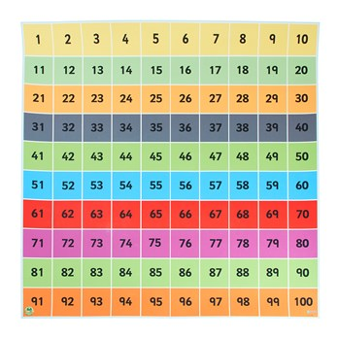
The children’s topic for next half term is ‘Towers, Tunnels and Turrets’. In our Science lessons this week, children have been learning about body parts such as hand, forearm, arm, leg. For their job, they labelled the different body parts on an outline of a human body.
In their following lesson, children learnt about the five senses; taste, touch, smell, hear and sight.

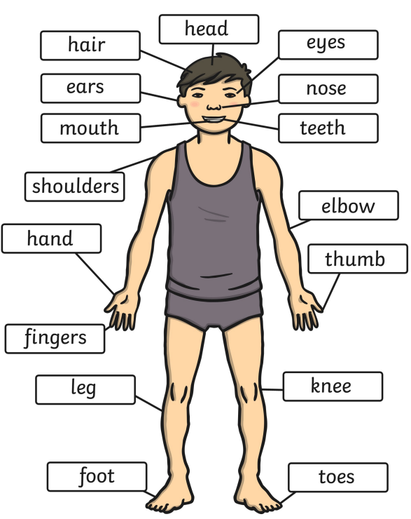

Can your child name their different body parts?
Can your child name the five senses?

Reminders:
All Year 1 children are doing PE on Thursdays. Children need a t-shirt, shorts (for indoor PE), long trousers (for outdoor PE), trainers and a jumper in their PE bags.
Year 2 children are swimming on Thursdays.

Attendance for KS1:
Class 7 – 94.6%
Class 8 – 98.3%
Class 9 – 97.5%

Homework
Homework will mainly be handed out on a Tuesday. On the odd occasion it may be on a different day due to timetable changes. Please return homework on a Monday. Handing it on a Monday gives you the opportunity before the weekend to ask the teacher any questions so that you are clear of how to support your child if unsure. There is a tray in each class where the homework needs to be returned. Please ask the teacher where this tray is if unsure.

Spellings
Spellings are handed out each Thursday and your child will be tested on these spellings the following Thursday. Children will receive a list of spellings to practise each week. In addition to the spellings, children will be tested on a sentence containing the words. However, the sentence will not be sent home. This is to see if they can apply the spelling currently within their writing. Can you get your child to practise applying the words by creating their very own sentences?

Reading Diaries
Children in KS1 have all been provided with a Home Reading Diary. Please fill this in daily based on your child reading a couple of pages of a book or a whole book. Please return the Reading Diary to school each day and leave it in their book bags. There are books situated in the classroom for your child to take home daily. Reading is extremely important to your child’s development so we really encourage your child to read a book or pages of a book daily. If you are unsure of your child’s reading book colour then please ask your teacher.

Online Safety
The Education for a Connected World framework is used by Royd Nursery Infant School to support in the delivery of online safety. It is a tool for anyone who works with children and young people. It enables the development of teaching and learning as well as guidance to support children and young people to live knowledgeably, responsibly and safely in a digital world.

It focuses specifically on eight different aspects of online education. Strand 5 focuses on “Managing online information”.

To view Strand 5 “Managing online information” please click on the following link and scroll to page 25 and 26 (if you would like to know more about this strand and what is covered from ages 7 – 18 please scroll to pages 27 – 30): https://assets.publishing.service.gov.uk/media/5efa05b4e90e075c5492d58c/UKCIS_Education_for_a_Connected_World_.pdf

Thank you
Miss Payne, Miss Howes & Miss Aldam

