
Weekly Newsletter
W.B. 16.12.24

We wish everybody a very Merry Christmas and a happy new year!

This week:

As part of Maths this week children have continued with their shape, space and measure learning. We have continued learning about length and height and have measured the length of different lines using a ruler and by counting on. We have also solved some length and height word problems.
After that, we started learning about mass. The children know when we are measuring how light or heavy an object is, we are measuring its mass. We measure mass in grams (g) and kilograms (kg).

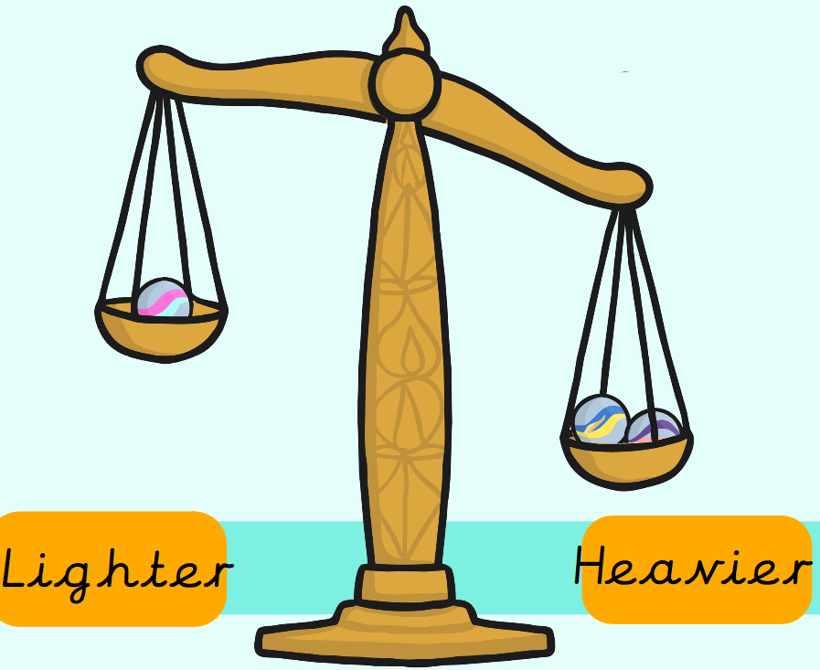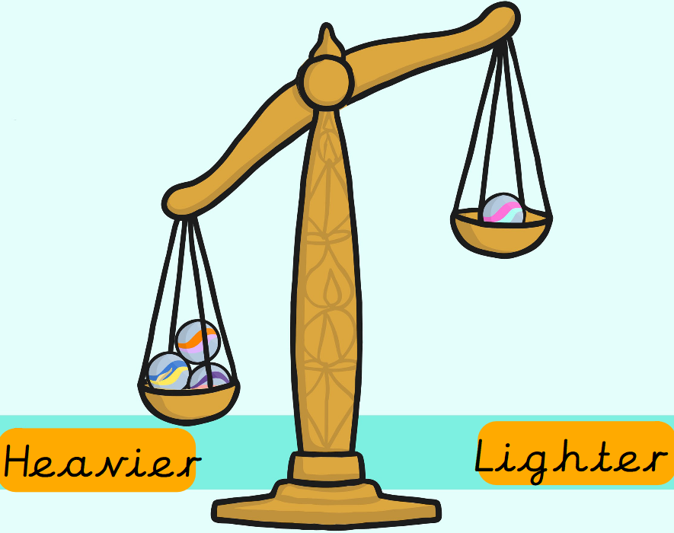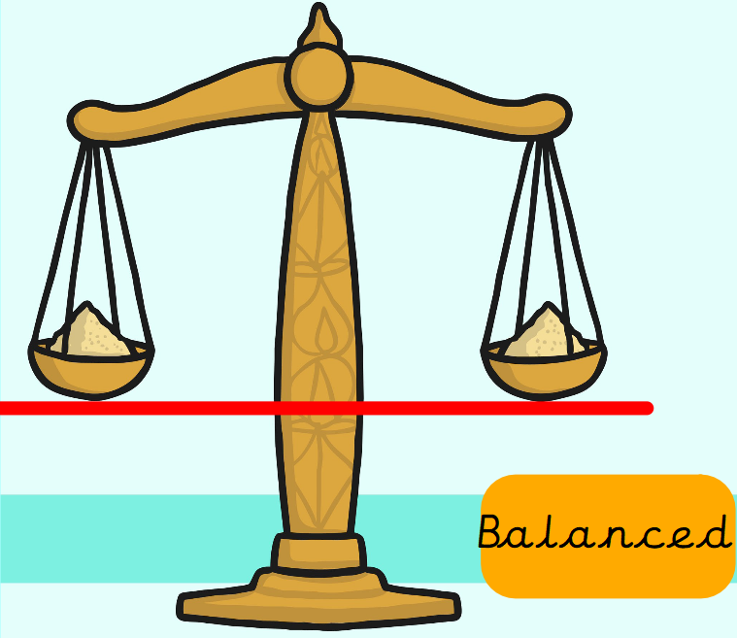

As part of topic lessons, children have started their geography learning. The children were shown a suitcase full of objects from around the world and had to guess what they were learning about – the seven continents! The children know that a continent is a word used to ‘describe large areas of land’. Their first activity was to research a continent in groups and design their own poster all about their chosen continent, which they then presented to the rest of their class.

Can your child name the seven continents?



Reminders:
Class 7 PE day (indoor and outdoor) is Thursday.
Class 8 PE days are Wednesday (outdoors) and Thursday (indoors).
Class 9 PE day (indoor and outdoor) is Thursday.

Children need a t-shirt, shorts (for indoor PE), long trousers (for outdoor PE), trainers and a jumper in their PE bags.

Attendance for KS1:
Class 7 – 96.5%
Class 8 – 97.2%
Class 9 – 96.4%

Homework
Homework will mainly be handed out on a Tuesday. On the odd occasion it may be on a different day due to timetable changes. Please return homework on a Monday. Handing it on a Monday gives you the opportunity before the weekend to ask the teacher any questions so that you are clear of how to support your child if unsure. There is a tray in each class where the homework needs to be returned. Please ask the teacher where this tray is if unsure.

Spellings
No spellings were handed out this week as new groups will be given in the first week back.

Reading Diaries
Children in KS1 have all been provided with a Home Reading Diary. Please fill this in daily based on your child reading a couple of pages of a book or a whole book. Please return the Reading Diary to school each day and leave it in their book bags. There are books situated in the classroom for your child to take home daily. Reading is extremely important to your child’s development so we really encourage your child to read a book or pages of a book daily. If you are unsure of your child’s reading book colour then please ask your teacher.

Online Safety
The below has been taken from GOV.UK and is guidance based on “Support for parents and carers to keep children safe online”.
While there are huge benefits to being online to stay connected to family and friends, the government recognises many parents feel concerned about the activities and content their children are accessing. This guidance outlines resources to help keep children safe from different risks online and where to go to get support and advice.
Keep your child safe online
It is important to have regular conversations about staying safe online and to encourage children to speak to you if they come across something worrying online.
Talk to your child about the importance of creating a safe online environment, including keeping any log-in details and passwords safe.
The below resource is designed to support you to talk to your child about a range of online safety issues, set up home filtering in a child-friendly way and set up age-appropriate parental controls on digital devices:
National Society for the Prevention of Cruelty to Children (NSPCC) - guidance for parents and carers to help keep children safe online https://www.nspcc.org.uk/keeping-children-safe/online-safety

Thank you
Miss Payne, Miss Howes & Miss Aldam

