
Weekly Newsletter
W.B. 10.3.25

If your child has accidentally taken the Reader, Writer or Mathematician t-shirts home, please return them to their class teacher.

As part of English this week we have continued our new focus around poetry. We have learnt about completing a cloze.
A cloze is a portion of text with missing words. The children had to write in the missing words from the poem. Later in the week, the children planned their own poem. They thought carefully about the different vocabulary to include in their writing and how they would change the theme. They have been very creative!

Can your child tell you the key features of a poem?
Can your child perform their poem to you from memory?
Can you guess the theme of their poem?

As part of Maths this week children have continued their addition and subtraction unit. We have used Numicon as well as number lines to solve addition and subtraction calculations within 20.

Can your child write calculations for the Numicon being shown below? (9 + 2 = 11 and 12 – 5 = 7)

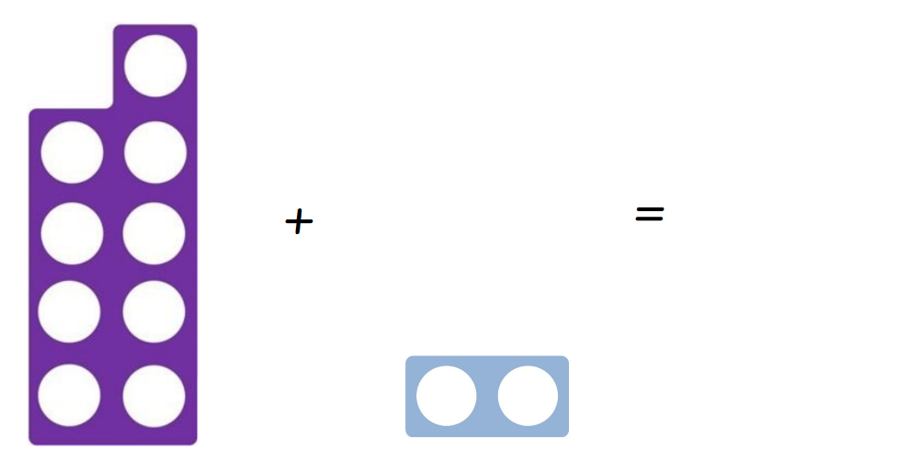
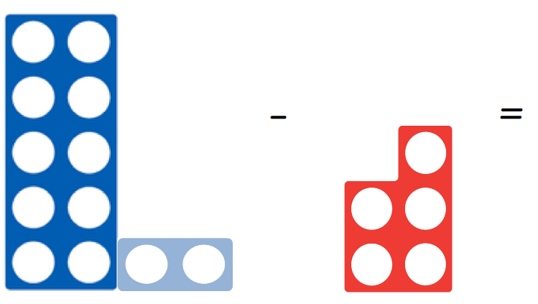

Our topic for this half term is ‘Bright Lights Big City’. As part of topic lessons, the children have started their Art learning. In Art, we have been looking at creating collages and symmetry. The children know that a collage is a piece of art made by sticking various materials (for example, paper/card) onto a backing. The children practised creating shape collages using 1 block colour first before creating a larger colourful collage of a city skyline.

Can your child tell you what a collage is?
Can your child explain what symmetrical means? (The same on both sides)

Reminders:
Class 7 PE day (indoor and outdoor) is Thursday.
Class 8 PE days are Wednesday (outdoors) and Thursday (indoors).
Class 9 PE day (indoor and outdoor) is Thursday.

Children need a t-shirt, shorts (for indoor PE), long trousers (for outdoor PE), trainers and a jumper in their PE bags.

Attendance for KS1:
Class 7 – 89.6%
Class 8 – 95.5%
Class 9 – 96.7%

Homework
Homework will mainly be handed out on a Tuesday. On the odd occasion it may be on a different day due to timetable changes. Please return homework on a Monday. Handing it on a Monday gives you the opportunity before the weekend to ask the teacher any questions so that you are clear of how to support your child if unsure. There is a tray in each class where the homework needs to be returned. Please ask the teacher where this tray is if unsure.

Spellings
Spellings are handed out each Thursday and your child will be tested on these spellings the following Thursday. Children will receive a list of spellings to practise each week. In addition to the spellings, children will be tested on a sentence containing the words. However, the sentence will not be sent home. This is to see if they can apply the spelling currently within their writing. Can you get your child to practise applying the words by creating their very own sentences?

Reading Diaries
Children in KS1 have all been provided with a Home Reading Diary. Please fill this in daily based on your child reading a couple of pages of a book or a whole book. Please return the Reading Diary to school each day and leave it in their book bags. There are books situated in the classroom for your child to take home daily. Reading is extremely important to your child’s development so we really encourage your child to read a book or pages of a book daily. If you are unsure of your child’s reading book colour then please ask your teacher.

Online Safety

Gaming: what parents and carers need to know
Gaming is extremely popular with children and young people. It can be difficult to keep up with the latest games and how they work. Here we take a look at key safety concerns and how you can support happier, safer gaming for your child.
To find out more information about “3 ways to make gaming safer for your child” as well as much more click on the following link: https://www.ceopeducation.co.uk/parents/articles/gaming/

Thank you
Miss Payne, Miss Howes & Miss Aldam

