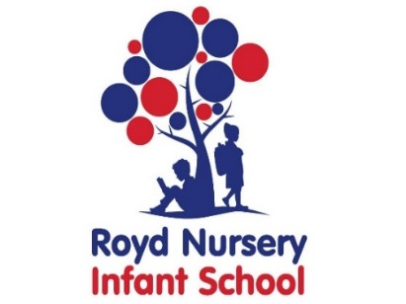

Royd Nursery Infant School

Carr Road, Deepcar

Sheffield, S36 2PR

Tel 0114 288 2594

Email [enquiries@royd.sheffield.sch.uk](mailto:enquiries@royd.sheffield.sch.uk)

[www.roydnurseryinfants.co.uk](http://www.roydnurseryinfants.co.uk)

Headteacher: Louise Jones

Dear Parents/Carers,

I am writing regarding the procedures for booking sessions at the Breakfast and Afterschool Club.

The current system is encountering problems due to payments not made in advance and we need to ensure the Breakfast and Afterschool Club is sustainable. With this in mind, a summary of the new procedure is below. Full details are on the school website with paper copies available at the respective school offices.

**Cost**

This is now £9.50 per session, per child.

* A Breakfast club session is anytime between 7am and the start of school/provision
* An Afterschool Club session is anytime between the end of the school day and 6pm.

**Booking using Parentpay**

Sessions must be booked in advance using ParentPay. For details of the dates when your booking must be received please refer to the school website. https://www.roydnurseryinfants.co.uk/breakfast-afterschool-clubs/. There is a link on how to book sessions using ParentPay in the Breakfast Club Policy and the Afterschool Club policy, both available on the school website.

**Emergency Booking Royd Nursery Infant School**

If your child attends Royd Nursery Infant school and you need to make any short notice bookings during school hours, you will need to contact the office at Royd Nursery Infant School on 0114 2882594. Subject to places being available immediate payment via card is to be made at the time of booking. Bank transfers are not acceptable. The school office will then inform staff of the changes

**Emergency Booking Deepcar St John’s C of E Junior School**

If your child attends Deepcar St John’s C of E Junior School and you need to make any short notice bookings during school hours, you will need to contact the office at Deepcar St John’s C of E at Royd Nursery Infant School on 0114 2883878. Subject to places being available immediate payment via card is to be made at the time of booking. Bank transfers are not acceptable. The school office will then inform staff of the changes

**Booking for families using Working Parent Entitlement (WPE) Hours**

Booking is to be made using the Breakfast and After-school Club WPE Booking form available on the school website https://www.roydnurseryinfants.co.uk/breakfast-afterschool-clubs/ and at the school office. For details of the dates when your form must be received, please refer to the school website.

Please note that from September 1st 2025, for new families accessing Early Years Provision, Working Parent Entitlement hours will no longer be accepted for breakfast and afterschool club. Any current families this does not apply.

**Booking for families using Childcare Vouchers/Childcare Grant Scheme**

Booking is to be made using the Breakfast and After-school Club Voucher Booking form available on the school website https://www.roydnurseryinfants.co.uk/breakfast-afterschool-clubs/ and at the school office. For details of the dates when your form must be received, please refer to the school website.

**Cancellation**

Please be aware that any cancellations for breakfast and afterschool club no refunds will be issued. If a child is on a school trip or residential again no refund will be issued. Further circumstances regarding refunds are detailed in the Breakfast Policy and Afterschool Club policy available on the school website.

The changes come into immediate effect and therefore, for families booking by Parentpay or using WPE you need to book now (14 – 21 April) for sessions during May 2025.

Thank you.

Yours sincerely,

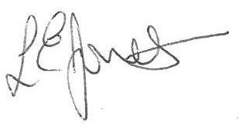

Louise Jones Sean Sly

Executive Head Acting Deputy Head





