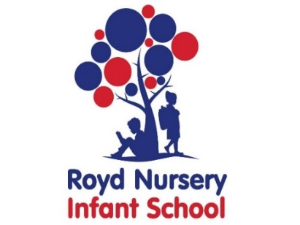

Royd Nursery Infant School

Carr Road, Deepcar

Sheffield, S36 2PR

Tel 0114 288 2594

Email [enquiries@royd.sheffield.sch.uk](mailto:enquiries@royd.sheffield.sch.uk)

[www.roydnurseryinfants.co.uk](http://www.roydnurseryinfants.co.uk)

Headteacher: Louise Jones

25 April 2025

Dear Parents/Carers,

This year marks the 80th anniversary of the end of the second world war and the Government has announced four days of celebrations across the country leading up to VE Day.

On Thursday 8th May 2025 Royd will be taking part in the VE Day celebrations.

Instead of uniform, children can wear red, white and/or blue (colours of the British flag) to school plus there will be party games and a tea party.

On the day of the celebration, children will have their school dinner as normal and the tea party will be later in the afternoon. (Snacks for the tea party will be provided by school with any medical diets/allergies adhered to.) Weather permitting, this will be outside followed by traditional party games such as musical statues etc.

Thank you.

Yours sincerely,

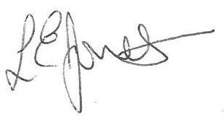

Louise Jones Sean Sly

Executive Head Acting Deputy Head





