
Weekly Newsletter
W.B. 21.4.25

This week in English the children have continued their story writing focus. We have been looking at key spelling rules for adding a range of suffixes to root words. We started off with the suffix ‘s’ and ‘es’ which changes a root word to either plural or a third person verb. We have also looked at the suffix ‘ed’ which makes words past tense and the suffix ‘ing’ which can make words present tense. After that, we learnt about the suffixes ‘er’ and est’. The suffix ‘er’ is used for comparing and is called a ‘comparative’ adjective and the suffix ‘est’ is used for comparing more than two things and is therefore a ‘superlative’ adjective. For example, this cake is tasty, that cake is tastier but those sweets are the tastiest. The children had to look at different words and decide which spelling rule needed to be applied.

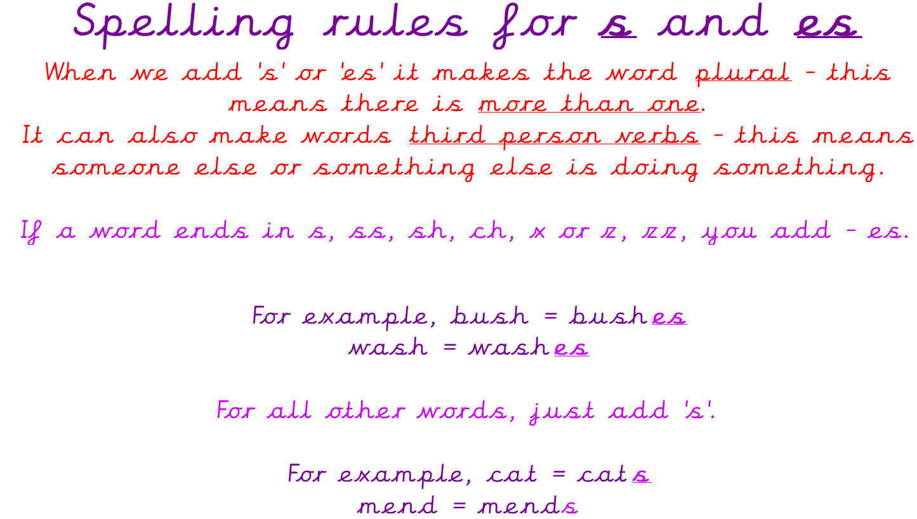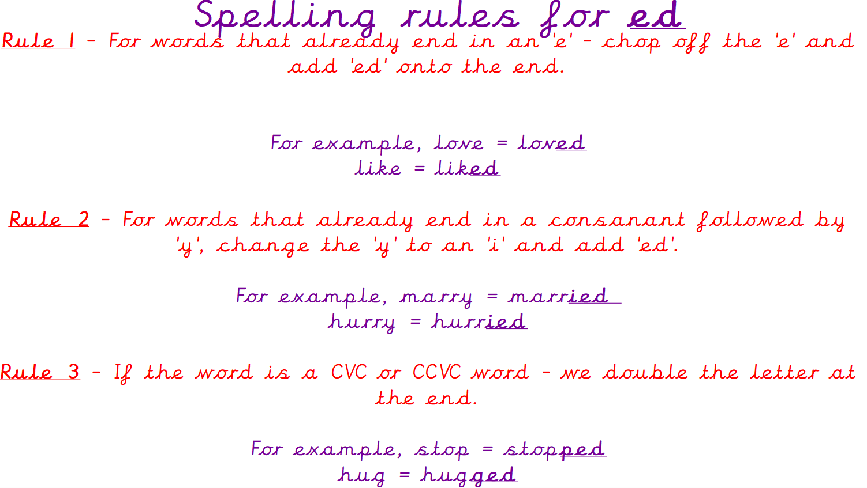
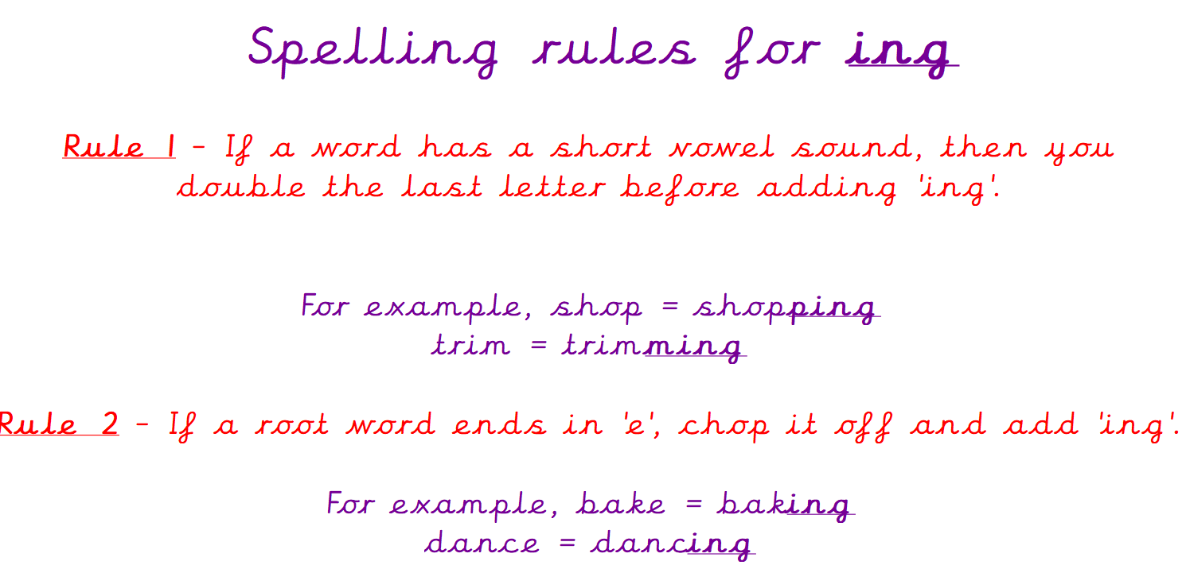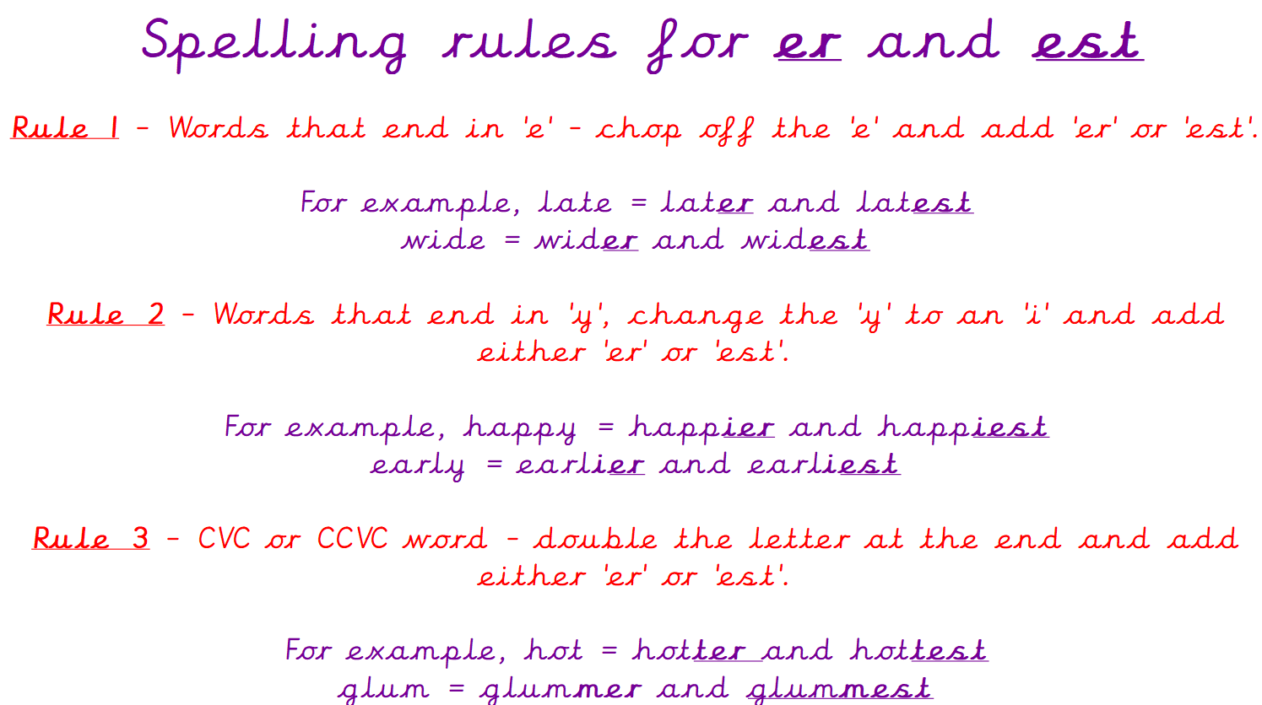

Can your child tell you the spelling rules for adding ‘s’ and ‘es’?
Can your child tell you what the suffixes ‘ed’, ‘ing’, ‘er’ and ‘est’ does to a root word?

As part of Maths this week children have continued their focus on addition and subtraction.
We have been learning how to solve difference calculations. We use the difference calculation method when numbers are close together, so we ‘count on’ to find our answer rather than subtracting. The children started by circling the start (smallest) number on their number line, working out where it would be if the number was missing and then count on to the next number to find the answer.
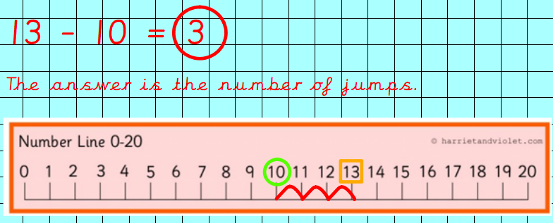
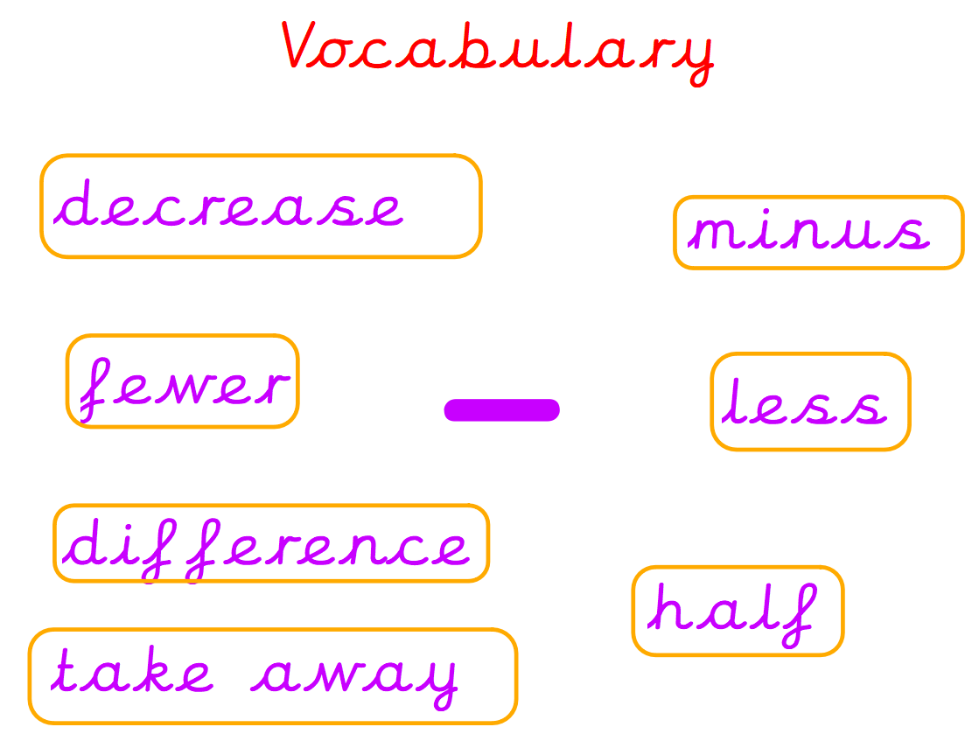

After that the children progressed onto learning how to solve calculations on a partial number line. We completed addition calculations, starting with the first number and counting on to the answer to find the missing number.

In topic, the children have also completed their DT learning and used different materials to create a 3D model of the bird’s eye view of our school wildlife garden.

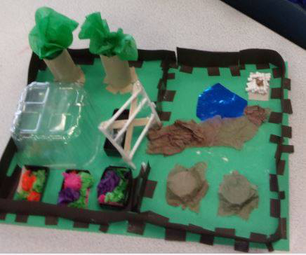

Can your child tell you the materials and joining methods they used to create their 3D model?

Reminders:
Class 7 PE day (indoor and outdoor) is Thursday.
Class 8 PE days are Wednesday (outdoors) and Thursday (indoors).
Class 9 PE day (indoor and outdoor) is Thursday.

Children need a t-shirt, shorts (for indoor PE), long trousers (for outdoor PE), trainers and a jumper in their PE bags.

Attendance for KS1:
Class 7 – 96%
Class 8 – 96%
Class 9 – 99%

Homework
Homework will mainly be handed out on a Tuesday. On the odd occasion it may be on a different day due to timetable changes. Please return homework on a Monday. Handing it on a Monday gives you the opportunity before the weekend to ask the teacher any questions so that you are clear of how to support your child if unsure. There is a tray in each class where the homework needs to be returned. Please ask the teacher where this tray is if unsure.

Spellings
Spellings are handed out each Thursday and your child will be tested on these spellings the following Thursday. Children will receive a list of spellings to practise each week. In addition to the spellings, children will be tested on a sentence containing the words. However, the sentence will not be sent home. This is to see if they can apply the spelling currently within their writing. Can you get your child to practise applying the words by creating their very own sentences?

Reading Diaries
Children in KS1 have all been provided with a Home Reading Diary. Please fill this in daily based on your child reading a couple of pages of a book or a whole book. Please return the Reading Diary to school each day and leave it in their book bags. There are books situated in the classroom for your child to take home daily. Reading is extremely important to your child’s development so we really encourage your child to read a book or pages of a book daily. If you are unsure of your child’s reading book colour then please ask your teacher.

Online Safety

Smartie the Penguin
A collection of six stories exploring life online for 3-7 year olds.
To view “The Adventures of Smartie the Penguin” and the series of six stories for use with 3 to 7 year olds to help explore life online and understand how and when to ask for help please click on the following link: https://www.childnet.com/resources/smartie-the-penguin/

Thank you
Miss Payne, Miss Howes & Miss Aldam

