
Weekly Newsletter
W.B. 21.4.25

This week in English the children have continued their story writing focus. We started off the week by looking at some key vocabulary from our story and some more/less effective words. We have looked at adjectives (describing words) and verbs (doing/being words) and located them in the story. We thought of some more ambitious words for them to help us improve our story writing vocabulary. We then moved onto learning key spelling rules for adding a range of suffixes to root words. We started off with the suffix ‘ly’ which changes a root word to an adverb. We also looked at the suffixes ‘ful’ and ‘ness’. The suffix ‘ful’ makes a word full of something. For example, beautiful is full of beauty. The suffix ‘ness’ is the state, quality or condition of something and it changes an adjective to a noun. For example, dirty -> dirtiness. The children had to look at different words and decide which spelling rule needed to be applied.
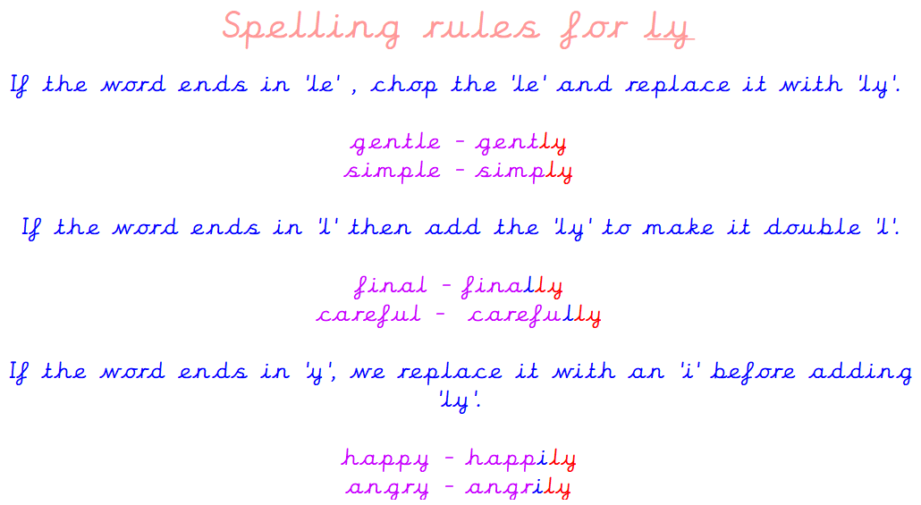
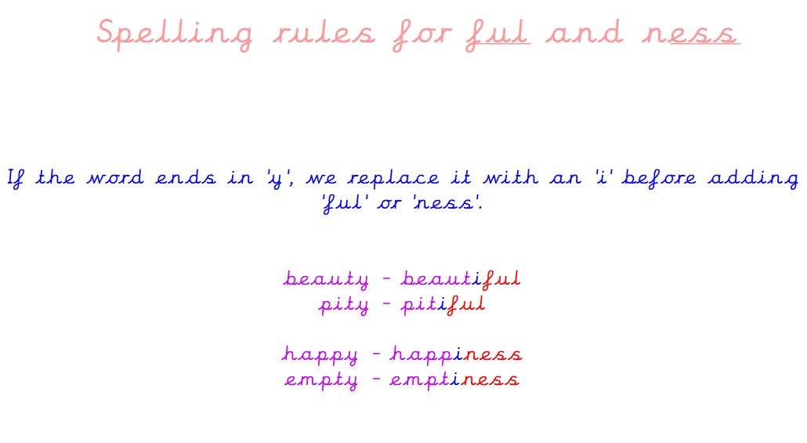

Can your child tell you what the suffix ‘ly’ does to a root word?
Can your child tell you the spelling rules for adding ‘ful’ to a root word?
Can your child tell you what the suffix ‘ness’ does to a root word?

As part of Maths this week, the children have continued their work on the partitioning and recombining method to help them solve addition and subtraction calculations. The children have become confident with this method and as a result have been able to apply their understanding of this method to solve word problems.

Partition means to break apart. E.g – 24 partitioned would be 20 and 4.
Recombine means to put back together. E.g- If we were to recombine 40 and 1, it would be 41.

The children have also used their understanding of this to help them solve a three-step calculation. Children have been encouraged to spot the addition they can see to then help them work out the missing number in the 3-step calculation.

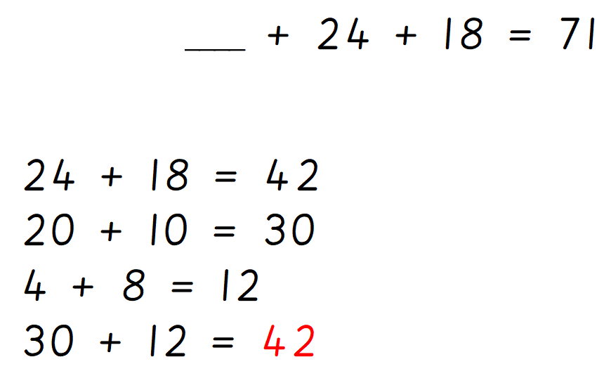

Can your child confidently count in multiples off the multiple? Can your child work out a 3-step calculation?

Can your child find a missing number in a calculation?

In topic, the children have also completed their DT learning and used different materials to create a 3D model of the bird’s eye view of our school wildlife garden.

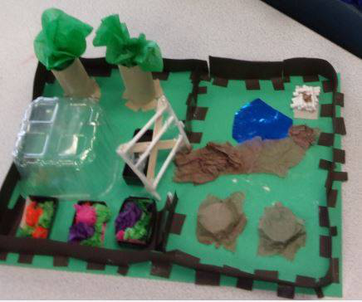

Can your child tell you the materials and joining methods they used to create their 3D model?

Reminders:
Class 7 PE day (indoor and outdoor) is Thursday.
Class 8 PE days are Wednesday (outdoors) and Thursday (indoors).
Class 9 PE day (indoor and outdoor) is Thursday.

Children need a t-shirt, shorts (for indoor PE), long trousers (for outdoor PE), trainers and a jumper in their PE bags.

Attendance for KS1:
Class 7 – 96%
Class 8 – 96%
Class 9 – 99%

Homework
Homework will mainly be handed out on a Tuesday. On the odd occasion it may be on a different day due to timetable changes. Please return homework on a Monday. Handing it on a Monday gives you the opportunity before the weekend to ask the teacher any questions so that you are clear of how to support your child if unsure. There is a tray in each class where the homework needs to be returned. Please ask the teacher where this tray is if unsure.

Spellings
Spellings are handed out each Thursday and your child will be tested on these spellings the following Thursday. Children will receive a list of spellings to practise each week. In addition to the spellings, children will be tested on a sentence containing the words. However, the sentence will not be sent home. This is to see if they can apply the spelling currently within their writing. Can you get your child to practise applying the words by creating their very own sentences?

Reading Diaries
Children in KS1 have all been provided with a Home Reading Diary. Please fill this in daily based on your child reading a couple of pages of a book or a whole book. Please return the Reading Diary to school each day and leave it in their book bags. There are books situated in the classroom for your child to take home daily. Reading is extremely important to your child’s development so we really encourage your child to read a book or pages of a book daily. If you are unsure of your child’s reading book colour then please ask your teacher.

Online Safety

Smartie the Penguin
A collection of six stories exploring life online for 3-7 year olds.
To view “The Adventures of Smartie the Penguin” and the series of six stories for use with 3 to 7 year olds to help explore life online and understand how and when to ask for help please click on the following link: https://www.childnet.com/resources/smartie-the-penguin/

Thank you
Miss Payne, Miss Howes & Miss Aldam

