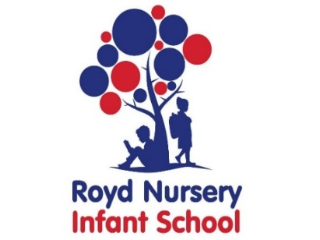

Royd Nursery Infant School

Carr Road, Deepcar

Sheffield, S36 2PR

Tel 0114 288 2594

Email [enquiries@royd.sheffield.sch.uk](mailto:enquiries@royd.sheffield.sch.uk)

[www.roydnurseryinfants.co.uk](http://www.roydnurseryinfants.co.uk)

Headteacher: Louise Jones

8 May 2025

Dear Parents/Carers

The topic next half term is ‘Can we explore it?’. In order to immerse our children in their learning we would like to take them to Eureka. The children will explore six different zones, each filled with interactive exhibits designed to inspire enquiring minds to find out about themselves and the world around them. Both Class 1 and Class 2 will be going on the trip on Wednesday 11th June 2025.

School is funding part of the trip so that the contribution is £26.00 per child.

The trip will be within school hours and we will be leaving at 9.00 am prompt and expect to be back at home time. If you would like to volunteer as helper, please inform your child’s class teacher.

It will be a full day visit. Children need to wear their school uniform with suitable clothing and footwear for walking around. Children will also need to bring their water bottle.

School will provide a packed lunch and the choice of sandwich is cheese or ham. Please make your choice on Parentpay when providing consent. If you wish to send your child with your own packed lunch, again please indicate on Parentpay.

If you would like your child to attend, contributions and consent are by Parentpay. Please complete this by Monday 2 June 2025. If there are any issues please do not hesitate to contact Mr Sly. Thank you.

Yours sincerely,

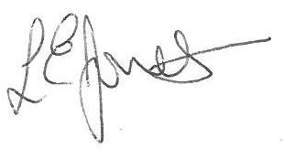

Louise Jones Sean Sly

Executive Head Acting Deputy Head





