
Weekly Newsletter
W.B. 12.5.25

This week has been Arts Week! Each class has focused on a different continent. Please see below.

Class 7 - South America:
In class 7, our focus for Arts Week has been around the continent South America. We have looked at the different animals that you might find there and we have also identified different structures and objects you might spot there too!

The children have thoroughly enjoyed making a range of artwork out of different media. We started the week making the statue ‘Christ the Redeemer’ and green anaconda snakes out of clay, looking very carefully at the shape and structure of them. We had to make sure we put plenty of water on the joins so they didn't fall apart when they dried. Whilst we left these aside to dry, we then started to create the Amazon River by carefully drawing the shape of the river and surroundings and then we added paint! To finish the day off, we thoroughly enjoyed a musical afternoon! First, we made our very own maracas whilst listening to South American music and then learned a samba dance. It was even more exciting that we got to use our hand-made maracas in the dance! We also got to perform it to the rest of the KS1 children!

On Tuesday, we absolutely loved learning about parrots and toucans which are native birds of South America. We followed Miss Bamford’s step-by-step guide in drawing the birds and paid close attention to detail to the shapes and lines. We made our birds look more effective by finishing them off with oil pastels. They looked vibrant! We had another musical themed afternoon and looked at the props that were used in the Carnival of Rio de Janeiro which is considered the biggest carnival in the world! We got into the carnival spirit and made replicas of the face masks and sombrero hats that are worn during the exciting festivals!

On Wednesday, we got the table covers out and spent the morning painting a background landscape for our city skylines. We wanted to create a sunset effect so we blended the colour gradients to create this look. We left these to dry, then they would be ready to add the skylines on to on Thursday. Following that, we spent a full afternoon working on a class project. We made a collage of the Amazon Rainforest using mixed media. We did this by working in small groups, carefully completing our section of the rainforest. Once they were all complete, we attached them all back together like a jigsaw puzzle to produce the final piece. It looked fantastic!

On Thursday, we continued our Amazon River creations by making them look more effective. We did this by adding mosaic details onto the river and scrunched up crepe paper onto the trees that were surrounding the river. The finished result looked amazing! After that, we learned about the red-eyed frog. The children thought it was amazing that this type of frog is one of the best-known amphibians in South America! (They especially loved its eyes!) We drew the frog on black paper and coloured it in with oil pastels to make it livelier. We started the afternoon by finishing our city skylines. We did this by drawing around a skyline then carefully cutting it out. We then stuck it neatly onto our sunset background to create a silhouette effect. To finish the day off, we finished off our clay models by adding the correct colour paint. We had to be extremely careful with the smaller details!

On Friday, we learned that cacti are native to the deserts in South America and have adapted to the dry, hot climate by storing water in their stems (interest huh?). We carefully drew a cactus on black paper and once that was done, we coloured them in using chalk pastels. We had to be extra careful not to smudge the bits we had already completed! We finished off our day by covering our clay models with PVA glue to make them extra shiny.

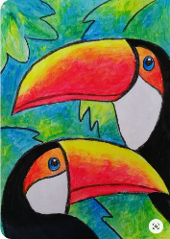
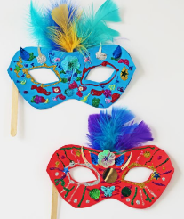
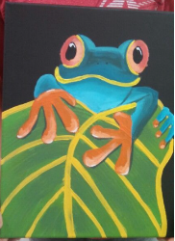
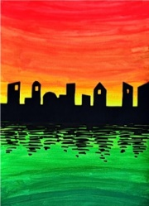

Class 8 – Europe:

In class 8, our focus for Arts Week has been around the continent Europe. We have looked at
the various landmarks, popular foods in different countries and we have also identified a variety
of animals that are native to Europe.
The children have thoroughly enjoyed making a range of artwork out of different media. We
started the week by recreating a snowy mountain scene just like the Alps! We used various
materials such as ear buds to paint the white snow drops and we cut out triangle shapes of
different sizes from green painted newspaper as the trees. At the end of the lesson, we had a
class discussion about the effects that global warming is having on the French Alps and the
children were excellent at contributing their ideas and thoughts! We then painted our King’s
crowns and we assembled them at the end of the week. In the afternoon, the Year 2s painted
tulips and the Year 1s painted a hedgehog. Both groups used forks to recreate the tulip bud or
the hedgehog spikes! Did you know that tulips are grown in the Netherlands and they grow 3
billion bulbs every year? At the end of the day, we discussed what Eurovision was and the
children then learned the song ‘Spaceman’ by Sam Ryder who was the winner in 2022! The
children couldn’t wait to perform to the rest of KS1 later on in the week!
On Tuesday, it was time to get messy! Using clay, we created pretzels, croissants and pizzas
(with our own toppings!). We had to carefully blend the parts together using water to ensure
they wouldn’t fall off when they dried. Then, we followed Miss Payne’s step-by-step guided in
drawing a seagull. Some children even added a fish to the seagull’s mouth! In the afternoon, the
children created Spanish dancers using paper plates and felt tip pens. They added a picture of
themselves to the face to make it look like they were the Spanish dancer! They also created a
lovely owl sitting on a branch collage using materials such as cotton wool to create the owl’s
body.
On Wednesday, the children loved discussing the seaside and what we could find at the beach in
different countries in Europe. We chose our favourite ice cream flavour and we recreated it
using collage. It was quite tricky but the children persevered and they looked great! Following
this, we created 3D beach huts and coloured them in using felt tip pens. Some children also
made a sun lounger using lollypop sticks! Then, in the afternoon, we discussed the artist Van
Gogh and we tried to replicate his famous sunflower drawings using oil pastels. The finished
result looked amazing! We then painted the background for our landmark silhouette creation
that we are doing later on in the week.
On Thursday, we created an image of the Northern Lights. We discussed how the Northern
Lights happen and where they happen. We used chalk on black paper and we first drew the
mountains and ground and then used the chalks in a stroking motion to create the Northern
Lights effect. After this, we learned our dance with Mr Stretton which we will perform later on
in the week to the other KS1 classes. We learned a flamingo dance which is popular in Spain. We
really focused on the arm movements and ensuring we are placing our hands in the correct
position. In the afternoon, we completed a collage in pairs as they were quite large! Half of the
class did a collage of the Leaning Tower of Pisa and the other half of the class did a surfboard.
The children had to carefully cut the small pieces and they had to think carefully about the
colours.
On Friday, we assembled the King’s crowns that we painted earlier in the week and we added
gems and sparkles to it. They looked excellent and the children looked like members of the royal
family! After that, we painting our clay models that we made earlier in the week. The children
focussed incredibly hard on adding the detail to make them come to life! Finally, we added the
silhouette of the famous European landmarks to our painted backgrounds and we completed
some symmetry animal paintings.

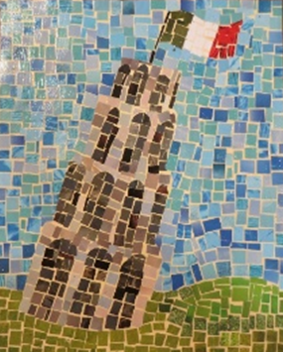
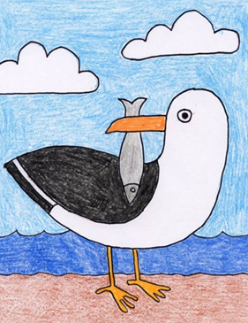
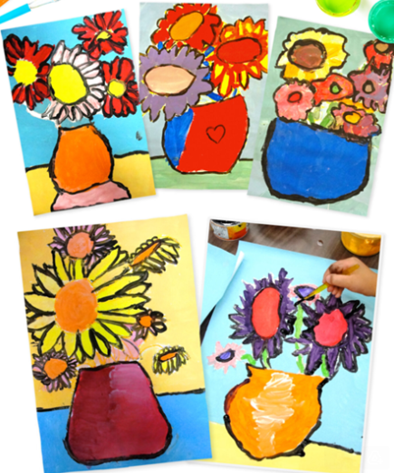
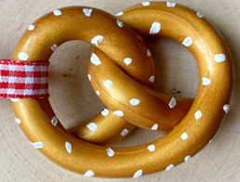

Class 9 – Africa:
In Class 9, our focus for Arts Week has been Africa! We have learnt many interesting facts about the animals which live in Africa and also other things you may find there!
On Monday, we created coloured African sunset shadow pictures. We painted our backgrounds the colours of a beautiful sunset before drawing and cutting out shadows of African animals onto black card. We then used chalk pastels to create a colourful lion’s head. After that, we drew an outline of an African lady’s head and coloured it in using a range of different pastels to make it abstract.
On Tuesday, we used clay to make African pots. The children carefully sculpted the shape of their pot before using tools to add patterns. Later in the morning, we made Zebra pictures using black chard and white chalk pastels to achieve the desired effect! Some children chose a different colour for their zebra such as purple or blue and made it abstract! In the afternoon, we drew a zebra’s eye on white card before using pastels and water colours to add colourful stripes around the zebra’s eye. Finally, we finished the day with a dance lesson focused on exploring Africa and dancing to African-themed music.
On Wednesday, we sketched an outline of an elephant before painting it grey and painting the background a bright colour. Once it was dry, we used pastels and coloured pens to add the finer details and colourful patterns onto the elephant’s body. Later in the day, we created African style paper plate necklaces using a range of coloured pens.

On Thursday, we drew a large giraffe and created a shape background before colouring it in using oil pastels. After that, we created a tropical tree collage using a variety of coloured paper, before adding a beautiful water colour sunset background. Later in the day, we created some beautiful African ladies and also a head collage. For our collage, we drew the outline of one side of a lady’s head onto black card. We then stuck string down to make our art work 3D. After that, we added other materials such as buttons and sequins to really bring the picture to life!

On Friday, we finished our African clay pots by painting them and then coating them with PVA glue to make them glossy. After that, we finished our Arts Week by learning some African music. We learnt about ‘the beat’ and used our beautiful singing voices to perform the song ‘Che Che Kule’ once we had learnt it.

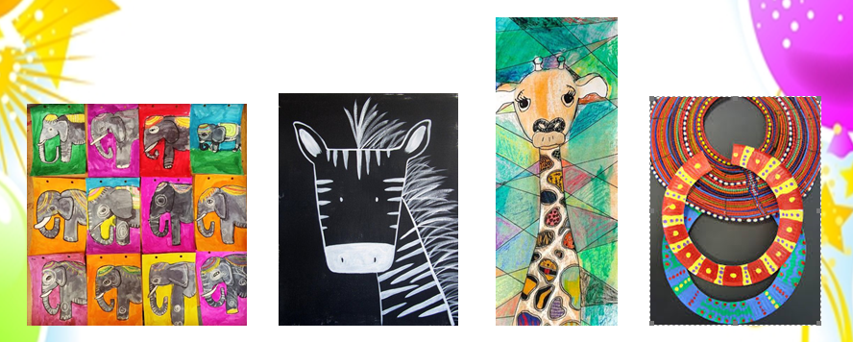

Reminders:
Class 7 PE day (indoor and outdoor) is Thursday.
Class 8 PE days are Wednesday (outdoors) and Thursday (indoors).
Class 9 PE day (indoor and outdoor) is Thursday.
Children need a t-shirt, shorts (for indoor PE), long trousers (for outdoor PE), trainers and a jumper in their PE bags.

Attendance for KS1:
Class 7 – 97%
Class 8 – 93%
Class 9 – 98%

Homework
Homework will mainly be handed out on a Tuesday. On the odd occasion it may be on a different day due to timetable changes. Please return homework on a Monday. Handing it on a Monday gives you the opportunity before the weekend to ask the teacher any questions so that you are clear of how to support your child if unsure. There is a tray in each class where the homework needs to be returned. Please ask the teacher where this tray is if unsure.

Spellings
Spellings are handed out each Thursday and your child will be tested on these spellings the following Thursday. Children will receive a list of spellings to practise each week. In addition to the spellings, children will be tested on a sentence containing the words. However, the sentence will not be sent home. This is to see if they can apply the spelling currently within their writing. Can you get your child to practise applying the words by creating their very own sentences?

Reading Diaries
Children in KS1 have all been provided with a Home Reading Diary. Please fill this in daily based on your child reading a couple of pages of a book or a whole book. Please return the Reading Diary to school each day and leave it in their book bags. There are books situated in the classroom for your child to take home daily. Reading is extremely important to your child’s development so we really encourage your child to read a book or pages of a book daily. If you are unsure of your child’s reading book colour then please ask your teacher.

Online Safety

National Online Safety – Online Safety Tips for Children
National Online Safety believe in empowering parents, carers and trusted adults with the information they need to hold informed and age-appropriate conversations about online safety with their child, should they feel it is needed. This weeks focus is “Online Safety Tips for Children”.

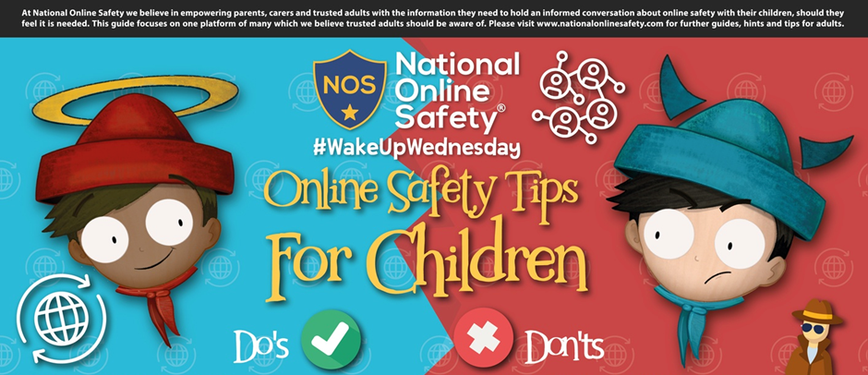

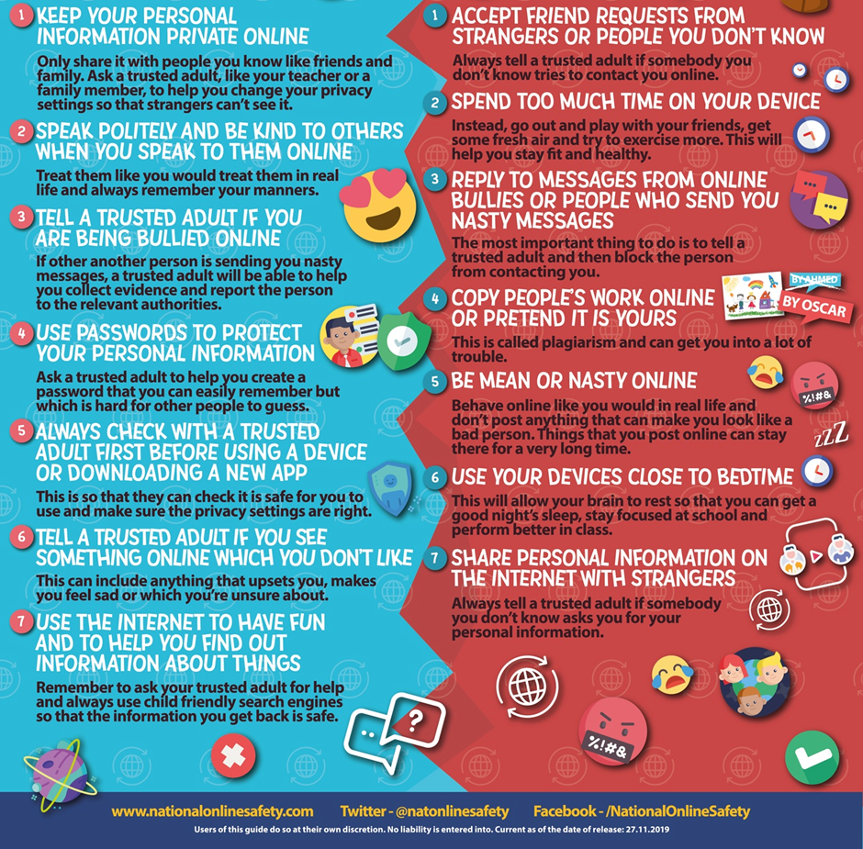

Thank you
Miss Payne, Miss Howes & Miss Aldam

