

Royd Nursery Infant School

Carr Road, Deepcar

Sheffield, S36 2PR

Tel 0114 288 2594

Email [enquiries@royd.sheffield.sch.uk](mailto:enquiries@royd.sheffield.sch.uk)

[www.roydnurseryinfants.co.uk](http://www.roydnurseryinfants.co.uk)

Headteacher: Louise Jones

9 June 2025

Dear Parent/Carers,

Parents Evening for Nursery, will take place on the following dates:

* Mrs Musgrave Thursday 7 July 2025 9.45 am to 11.30 am
* Mrs Musgrave Tuesday 8 July 2025 3.30 pm to 6.00 pm
* Miss Terry Wednesday 9 July 2025 9.15 am to 11.30am
* Miss Terry Thursday 10 July 2025 3.30 pm to 6.00 pm

Parent/carers will be able to come in to the classroom for their appointment. The procedure will be for parent/carers to arrive outside the Nursery building two minutes before the appointment time. The teacher will then come out to collect you.

To ensure that everybody has a fair chance of booking an appointment, please complete the form overleaf indicating your preference and return the form by Thursday 26 June 2025 at the latest and School will endeavour to meet your request.

Confirmation of appointment times will be sent by email on the afternoon of Monday 30 June 2025. Thank you.

Yours sincerely,

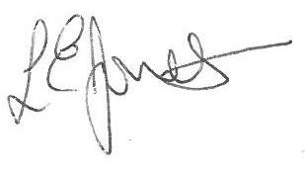

Louise Jones Sean Sly

Executive Head Acting Deputy Head







-----------------------------------------------------------------------------------------------------------------------------------------------

**Nursery Parents Evening July 2025**

**Name of Child** : Class FS1

Monday 7 July 2025 between 9.15 am to 11.30 am

Tuesday 8 July 2025 between 3.30 pm and 5.50 pm

Wednesday 9 July 2025 between 9.15 am and 11.30 am

Thursday 10 July 2025 between 3.30pm – 5.50 pm