

Royd Nursery Infant School

Carr Road, Deepcar

Sheffield, S36 2PR

Tel 0114 288 2594

Email [enquiries@royd.sheffield.sch.uk](mailto:enquiries@royd.sheffield.sch.uk)

[www.roydnurseryinfants.co.uk](http://www.roydnurseryinfants.co.uk)

Headteacher: Louise Jones

20 May 2025

Dear Parent/Carers,

Our topic next term is ‘Land Ahoy’ and as part of our work we have planned a visit for the KS1 children to The Deep in Hull. Classes 7, 8 and 9 will be going on Wednesday 25 June 2025. The contribution is £24 per child to cover transport cost and entrance fee.

The trip will be within school hours and children need to be in class for 8.30 am as we will be leaving at 8.45 am prompt. We will arrive back at school at approximately 3.30 pm. Should the coach be late back, please wait in the school hall.

It will be a full day visit. Children need to wear their school uniform with suitable clothing and footwear for walking around. Children will also need to bring their water bottle.

School will provide a packed lunch and the choice of sandwich is cheese or ham. Please make your choice on Parentpay when providing consent. If you wish to send your child with your own packed lunch, again please indicate on Parentpay.

If you would like your child to attend, contributions and consent are by Parentpay. Please complete this by Friday 20 June 2025. If there are any issues, please do not hesitate to contact Mr Sly. Thank you.

Yours sincerely,

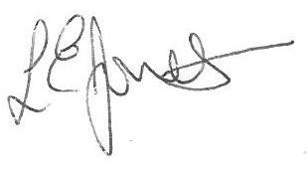



Louise Jones Sean Sly

Executive Head Acting Deputy Head





