
Weekly Newsletter
W.B. 2.6.25

On Thursday 12th June, your child will be handed spellings to practise at home but they will not be tested on them on Thursday 19th June due to school trips. On Wednesday 18th June, your child will be handed spellings that will be tested on Thursday 26th June.

This week:

This week in our English the children have started their poetry focus. We started off by reading a poem and learning it.
We created actions for the poem to help us remember it. We then moved onto analysing the poem; identifying the steps for success including, lines, stanzas and changing the theme.
Following this, we looked at pictures of pirates and their ships and described them, thinking about the colour, texture and what it might feel like to be on one of them.
After this, we used our knowledge of stanzas and order of the poem to reorder it by choosing which line comes first and which might come next.

As part of Maths the children have continued their work around multiplication and division. This week the children have progressed to using multiplication grids to solve problems surrounding their knowledge of 2, 3, 5, and 10 times tables. Not only does this focus on multiplication and division but children also have to use their addition skills. The children continue to work incredibly hard and always have a challenge completed in their book, it’s fantastic to see the children pushing themselves and always trying their best!

Can your child count in multiples of 2’s, 3’s, 5’s and 10’s?
Can they draw a multiplication grid to help them solve multiplication problems?
Can your child partition a 2-digit number into tens and ones?

Our topic for this half term is ‘Moon Zoom’. In History, the children spent time with a local historian who told us all about Samuel Fox and the history of the umbrella. The children then focussed on memories. We have had lots of opportunities to discuss and share our own special memories and experiences as a class. We used our own history and memories to create personal timelines, comparing our experiences and memories from the past to now.

Can your child put these milestones into the correct order? – first day at school, walking, talking.

Reminders:
Class 7 PE day (indoor and outdoor) is Thursday.
Class 8 PE days are Wednesday (outdoors) and Thursday (indoors).
Class 9 PE day (indoor and outdoor) is Thursday.

Children need a t-shirt, shorts (for indoor PE), long trousers (for outdoor PE), trainers and a jumper in their PE bags.

Attendance for KS1:
Class 7 – 97%
Class 8 – 96%
Class 9 – 95%

Homework
Homework will mainly be handed out on a Tuesday. On the odd occasion it may be on a different day due to timetable changes. Please return homework on a Monday. Handing it on a Monday gives you the opportunity before the weekend to ask the teacher any questions so that you are clear of how to support your child if unsure. There is a tray in each class where the homework needs to be returned. Please ask the teacher where this tray is if unsure.

Spellings
On Thursday 12th June, your child will be handed spellings to practise at home but they will not be tested on them on Thursday 19th June due to school trips. On Wednesday 18th June, your child will be handed spellings that will be tested on Thursday 26th June.

Reading Diaries
Children in KS1 have all been provided with a Home Reading Diary. Please fill this in daily based on your child reading a couple of pages of a book or a whole book. Please return the Reading Diary to school each day and leave it in their book bags. There are books situated in the classroom for your child to take home daily. Reading is extremely important to your child’s development so we really encourage your child to read a book or pages of a book daily. If you are unsure of your child’s reading book colour then please ask your teacher.

Online Safety

National Online Safety – Roblox
National Online Safety believe in empowering parents, carers and trusted adults with the information they need to hold informed and age-appropriate conversations about online safety with their child, should they feel it is needed. This weeks focus is “Roblox”. Please note that only children aged 7+ should be accessing this.

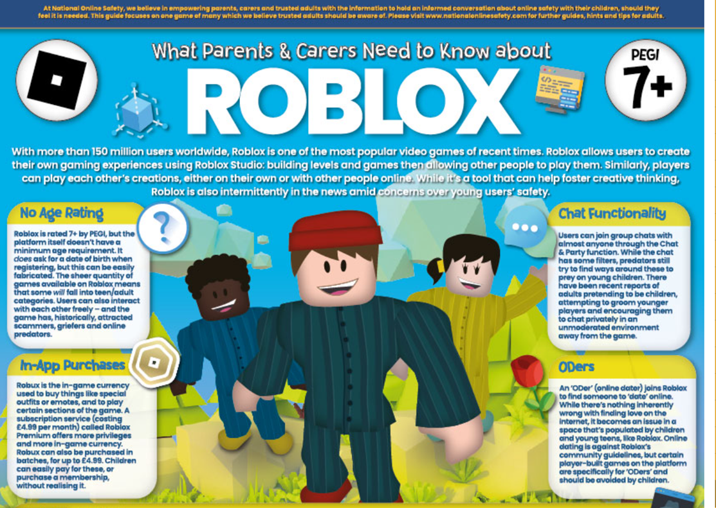

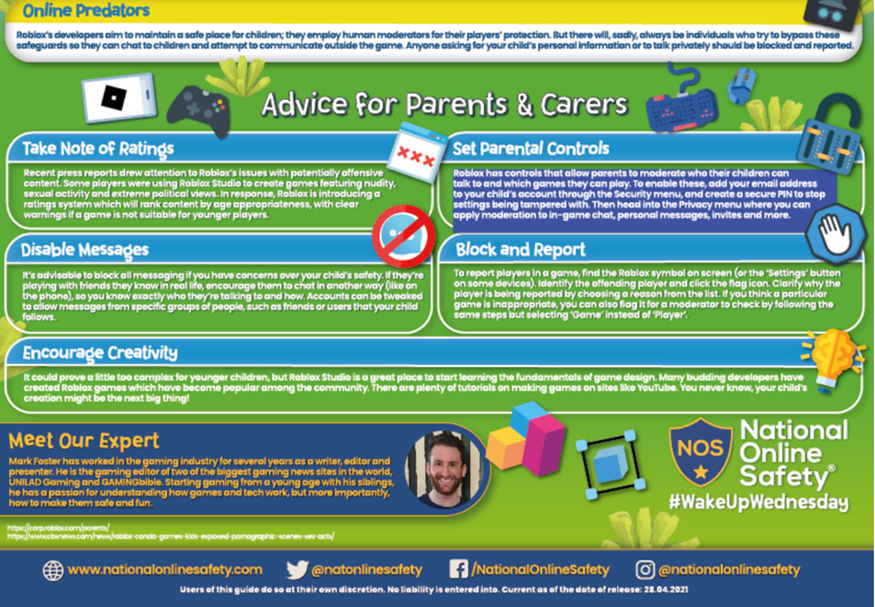

Thank you
Miss Payne, Miss Howes & Miss Aldam

