
Weekly Newsletter
W.B. 9.6.25

On Thursday 12th June, your child will be handed spellings to practise at home but they will not be tested on them on Thursday 19th June due to school trips. On Wednesday 18th June, your child will be handed spellings that will be tested on Thursday 26th June.

This week:

As part of Maths, children continued learning multiplication and this week have been focusing on multiplying by 10 using Numicon boards and pegs. They have also worked on using this method to solve a list of mixed calculations, multiplying by 2, 5 or 10.
The children know that when we multiply by 2 we have to count in 2s to find the answer. For example,
3 X 2 = you have to count in 2s three times to find the answer to 3 lots of 2.

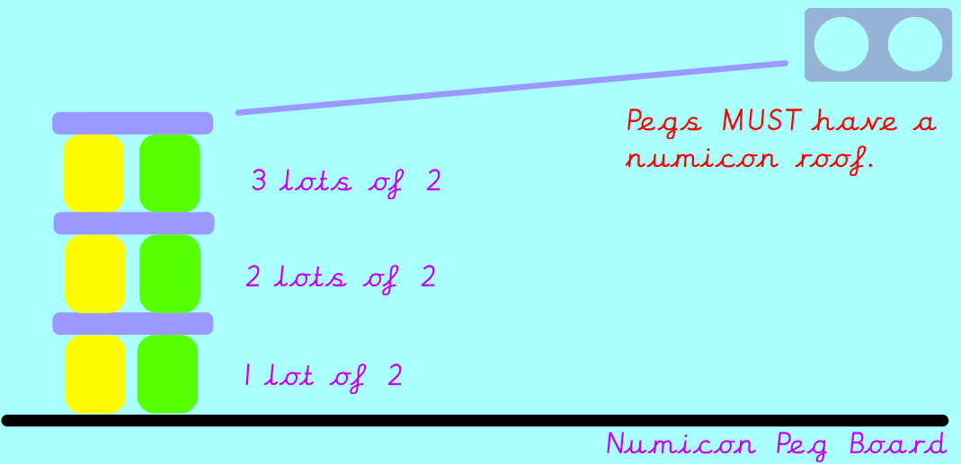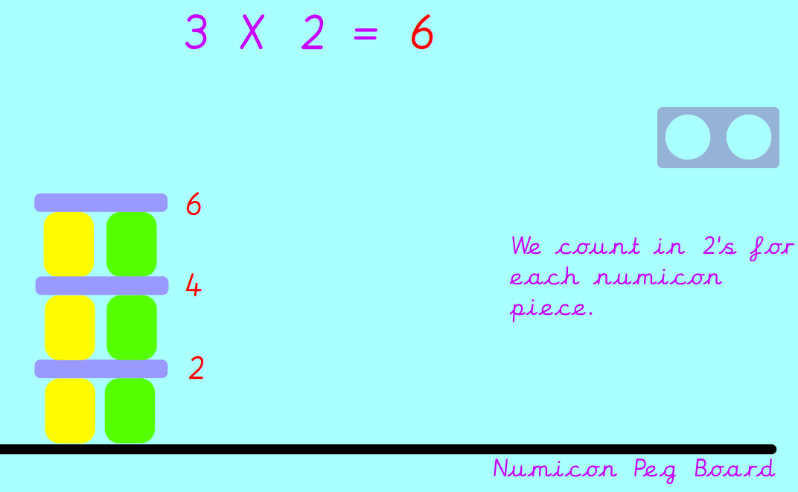

We then started to look at our 5 times tables and 10 times tables using the same method.

Can your child solve the following?
8 X 2 =
3 X 5 =
6 X 10 =

Our topic for this half term is ‘Moon Zoom’. In their Computing slots, Year 1 have been learning about and recording Pictograms on Purple Mash. In Geography, we are also focusing on data collection. We wanted to find out the number of coloured cars that passed school and if more cars were travelling up the hill or down the hill. We observed this by taking a record outside of school. We took clipboards and pencils and recorded our data using a pictogram.

Did more cars travel up the hill or down the hill? Why do you think this is?

Reminders:
Class 7 PE day (indoor and outdoor) is Thursday.
Class 8 PE days are Wednesday (outdoors) and Thursday (indoors).
Class 9 PE day (indoor and outdoor) is Thursday.

Children need a t-shirt, shorts (for indoor PE), long trousers (for outdoor PE), trainers and a jumper in their PE bags.

Attendance for KS1:
Class 7 – 90.9%
Class 8 – 93.8%
Class 9 – 91.1%

Homework
Homework will mainly be handed out on a Tuesday. On the odd occasion it may be on a different day due to timetable changes. Please return homework on a Monday. Handing it on a Monday gives you the opportunity before the weekend to ask the teacher any questions so that you are clear of how to support your child if unsure. There is a tray in each class where the homework needs to be returned. Please ask the teacher where this tray is if unsure.

Spellings
On Thursday 12th June, your child will be handed spellings to practise at home but they will not be tested on them on Thursday 19th June due to school trips. On Wednesday 18th June, your child will be handed spellings that will be tested on Thursday 26th June.

Reading Diaries
Children in KS1 have all been provided with a Home Reading Diary. Please fill this in daily based on your child reading a couple of pages of a book or a whole book. Please return the Reading Diary to school each day and leave it in their book bags. There are books situated in the classroom for your child to take home daily. Reading is extremely important to your child’s development so we really encourage your child to read a book or pages of a book daily. If you are unsure of your child’s reading book colour then please ask your teacher.

Online Safety

National Online Safety – iPads
National Online Safety believe in empowering parents, carers and trusted adults with the information they need to hold informed and age-appropriate conversations about online safety with their child, should they feel it is needed. This weeks focus is “iPads”.

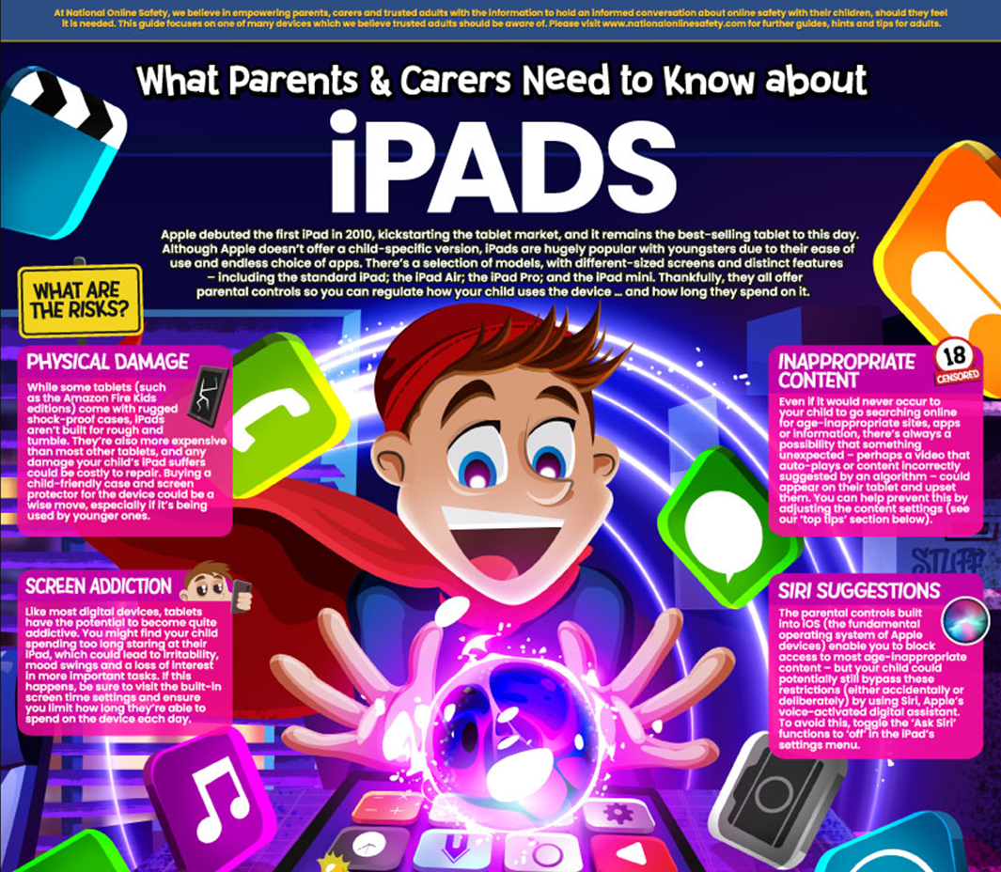

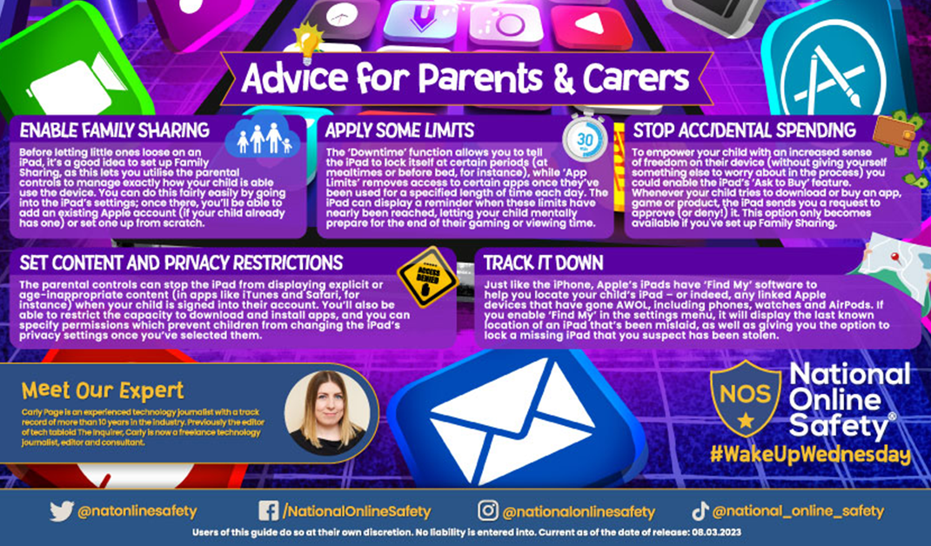

Thank you
Miss Payne, Miss Howes & Miss Aldam

