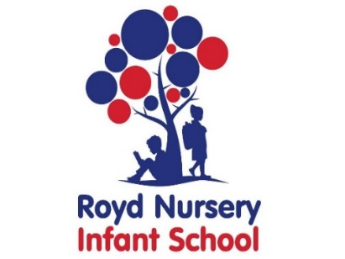

Royd Nursery Infant School

Carr Road, Deepcar

Sheffield, S36 2PR

Tel 0114 288 2594

Email [enquiries@royd.sheffield.sch.uk](mailto:enquiries@royd.sheffield.sch.uk)

[www.roydnurseryinfants.co.uk](http://www.roydnurseryinfants.co.uk)

Headteacher: Louise Jones

10 June 2025

Dear Parent/Carers,

easyfundraising is the UK’s biggest charity fundraising platform.

At easyfundraising they turn everyday online shopping into free donations for your good cause. Free and easy to use, easyfundraising has helped good causes raise over £50 million since 2005.

easyfundraising partners with thousands of brands, so when an online shopper makes a purchase, the brand donates a percentage of what they’ve spent to your cause and it’s entirely free.

It doesn’t cost you a penny more

The great thing is it won’t cost you any more, plus they’ve got lots of voucher codes and special discounts so you can actually save money while you help your good cause. There is no cost for the good cause either – their service is totally free.

How to generate donations

It's very simple - once you've registered with easyfundraising, simply shop with one of their retailers, their system then makes a note of your purchase, you generate cashback from the retailer, and easyfundraising then pass this donation on your behalf to your chosen cause (Royd Nursery Infant School). That's it! No hassle for you, we do all the hard work while you shop as you normally would.

To select Royd Nursery Infant School as your chosen cause please click on the following link:

<https://www.easyfundraising.org.uk/support-a-good-cause/step-1/?char=5831&invite=15RCED&referral-campaign=s2s&utm_source=easyfundraising-app&utm_medium=referral&utm_content=share-tray>

For any further information please visit:

<https://www.easyfundraising.org.uk/assets/blt7a6b727752b54c24/easyfundraising-guide-starterpack.pdf>

Yours sincerely,

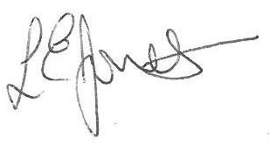

Louise Jones Sean Sly

Executive Head Acting Deputy Head





