

Royd Nursery Infant School

Carr Road, Deepcar

Sheffield, S36 2PR

Tel 0114 288 2594

Email [enquiries@royd.sheffield.sch.uk](mailto:enquiries@royd.sheffield.sch.uk)

[www.roydnurseryinfants.co.uk](http://www.roydnurseryinfants.co.uk)

Headteacher: Louise Jones

14 July 2025

Dear Parents/Carers

For children in FS2, Y1 and Y2 we are running several extra curricular activities during the Autumn 1 half term. The activities, times and dates are detailed below.

On the day of the activity at the end of the school day, children are taken to the hall by their Teacher. At the end of the session collection is from the school main entrance next to the office. Please ensure whoever collects your child has your password that was provided to school. This will enable all activity leaders to identify you as parents/carers when you collect your child as well as identifying any different adults that may also collect them.

For your child to attend, please log on to Parentpay then select and pay for the club/s you wish your child to attend. Please note this will be on a first come first served basis.

Thank you,

Yours sincerely,

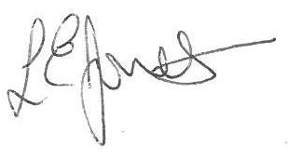

Louise Jones Sean Sly

Executive Head Acting Deputy Head

-------------------------------------------------------------------------------------------------------------------  
**Extra Curricular Activities Autumn 1 2025**

**MONDAY**

Dance FS2/Y1/Y2 3.20pm – 4.20pm 8 Sept – 20 Oct £31.50

**WEDNESDAY**

Football FS2/Y1//Y2 3.30pm – 4.30pm 10 Sept – 22 Oct £31.50

**THURSDAY**

Pottery FS2/Y1/Y2 3.20pm – 4.20pm 11 Sept – 23 Oct £31.50





