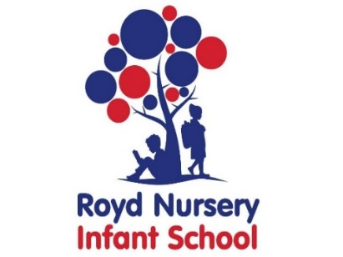

Royd Nursery Infant School

Carr Road, Deepcar

Sheffield, S36 2PR

Tel 0114 288 2594

Email [enquiries@royd.sheffield.sch.uk](mailto:enquiries@royd.sheffield.sch.uk)

[www.roydnurseryinfants.co.uk](http://www.roydnurseryinfants.co.uk)

Headteacher: Louise Jones

11 July 2025

Dear Parents/Carers

For children in FS2, Y1 and Y2 we are running several extra curricular activities during the Autumn half term. Currently there is no club on Friday. As usual, Pottery is split equally between each year group, please select and pay for the club according to your child’s year group;

The Kiln FS2 Autumn 1 2025

The Kiln Year 1 Autumn 1 2025

The Kiln Year 2 Autumn 1 2025

For your child to attend any of the extra curricular clubs, please log on to Parentpay then select and pay for the club/s you wish your child to attend. This will be on a first come first served basis and the places become available later today. Thankyou.

Yours sincerely,

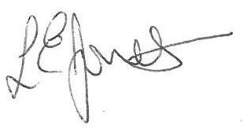

Louise Jones Sean Sly

Executive Head Acting Deputy Head

-------------------------------------------------------------------------------------------------------------------

**Extra Curricular Activities Autumn 1 2025**

**MONDAY**

Dance FS2/Y1/Y2 3.20pm – 4.20pm 8 Sept – 20 Oct £31.50

**TUESDAY**

Choir Y1/Y2 3.20pm – 4.00pm 9 Sept – 21 Oct £1.00

**WEDNESDAY**

Football FS2/Y1//Y2 3.30pm – 4.30pm 10 Sept – 22 Oct £31.50

**THURSDAY**

Pottery FS2/Y1/Y2 3.20pm – 4.20pm 11 Sept – 23 Oct £31.50





