
Weekly Newsletter
W.B. 16.6.25

This week:

This week in our English the children have continued their poetry focus. This week, we have analysed our poems focusing on the steps for success; lines, stanzas and change the theme.

Can your child tell you some of the key theme words from their poem?

As part of Maths, the children have continued their unit of multiplication and division. The children have recapped how to multiply by 2, 5 and 10 using arrays.

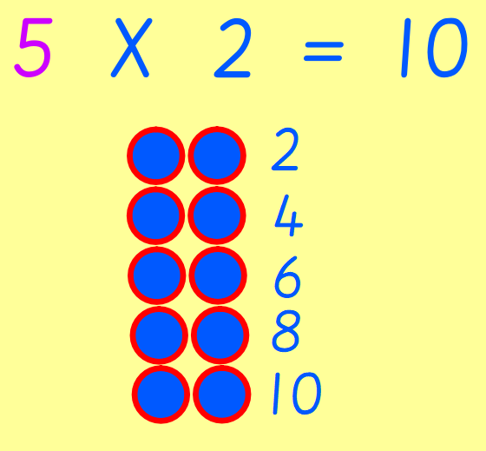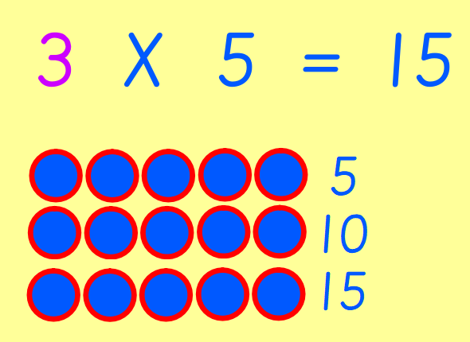

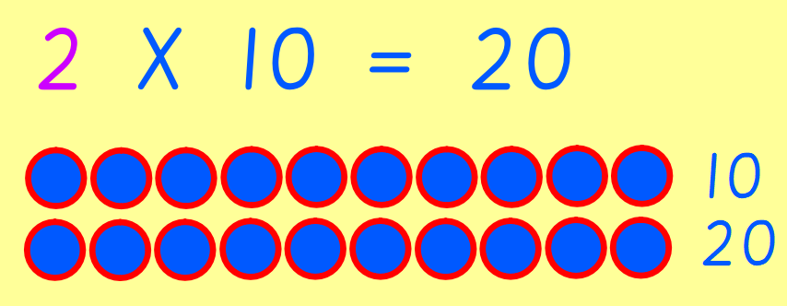

Can your child solve the following by drawing arrays?
7 X 2 =
2 X 5 =
4 X 10 =

Our topic for this half term is ‘Moon Zoom’. Geography, the children used the data they recorded on their pictogram last week to create a pictogram on Purple Mash. After that, they answered questions about the data.

How many red cars travelled up/down the hill?
Did more cars travel up the hill or down the hill? Why do you think this is?

Reminders:
Class 7 PE day (indoor and outdoor) is Thursday.
Class 8 PE days are Wednesday (outdoors) and Thursday (indoors).
Class 9 PE day (indoor and outdoor) is Thursday.

Children need a t-shirt, shorts (for indoor PE), long trousers (for outdoor PE), trainers and a jumper in their PE bags.

Attendance for KS1:
Class 7 – 96.5%
Class 8 – 95.5%
Class 9 – 94.1%

Homework
Homework will mainly be handed out on a Tuesday. On the odd occasion it may be on a different day due to timetable changes. Please return homework on a Monday. Handing it on a Monday gives you the opportunity before the weekend to ask the teacher any questions so that you are clear of how to support your child if unsure. There is a tray in each class where the homework needs to be returned. Please ask the teacher where this tray is if unsure.

Spellings
Spellings are handed out each Thursday and your child will be tested on these spellings the following Thursday. Children will receive a list of spellings to practise each week. In addition to the spellings, children will be tested on a sentence containing the words. However, the sentence will not be sent home. This is to see if they can apply the spelling currently within their writing. Can you get your child to practise applying the words by creating their very own sentences?

Reading Diaries
Children in KS1 have all been provided with a Home Reading Diary. Please fill this in daily based on your child reading a couple of pages of a book or a whole book. Please return the Reading Diary to school each day and leave it in their book bags. There are books situated in the classroom for your child to take home daily. Reading is extremely important to your child’s development so we really encourage your child to read a book or pages of a book daily. If you are unsure of your child’s reading book colour then please ask your teacher.

Online Safety

National Online Safety – Minecraft
National Online Safety believe in empowering parents, carers and trusted adults with the information they need to hold informed and age-appropriate conversations about online safety with their child, should they feel it is needed. This weeks focus is “Minecraft”. Please note that only children aged 7+ should be accessing this.



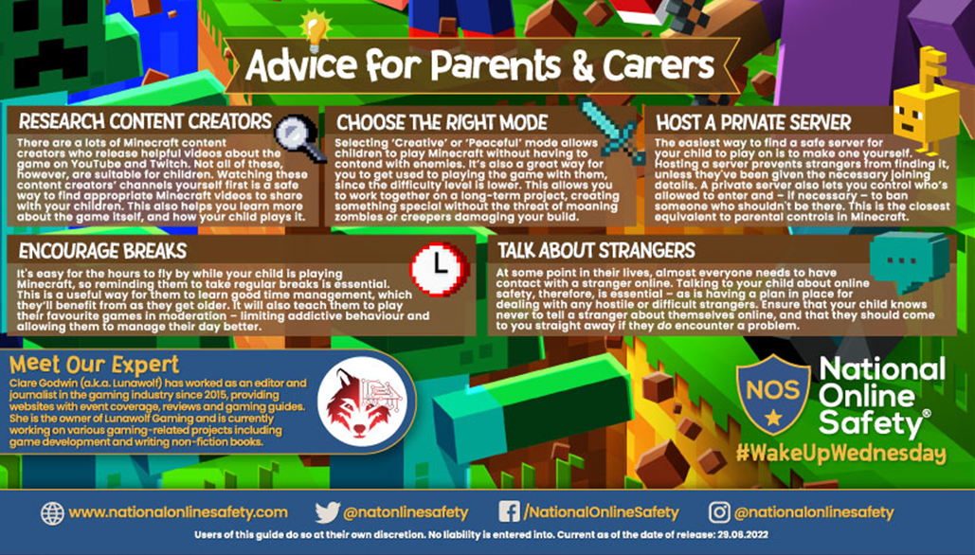

Thank you
Miss Payne, Miss Howes & Miss Aldam

