

Royd Nursery Infant School

Carr Road, Deepcar

Sheffield, S36 2PR

Tel 0114 288 2594

Email [enquiries@royd.sheffield.sch.uk](mailto:enquiries@royd.sheffield.sch.uk)

[www.roydnurseryinfants.co.uk](http://www.roydnurseryinfants.co.uk)

Headteacher: Louise Jones

12 September 2025

Dear Parents/Carers

For children in FS2, Y1 and Y2 another extra curricular club has been arranged. It will run for 6 weeks beginning tomorrow, Tuesday 16 September 2025 from 3.20 pm – 4.20 pm.

Learn a New Sport is being run by a new tutor from Links. For your child to attend, please log on to Parentpay then select and pay for the club.

For our new families in Reception, please ring or email school to book a place as you will not have a Parentpay login. Thank you..

Places are on a first come first served basis and are available now.

Yours sincerely,

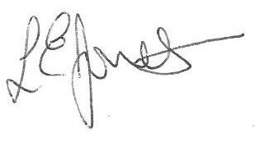

Louise Jones Sean Sly

Executive Head Acting Deputy Head





