

Royd Nursery Infant School

Carr Road, Deepcar

Sheffield, S36 2PR

Tel 0114 288 2594

Email [enquiries@royd.sheffield.sch.uk](mailto:enquiries@royd.sheffield.sch.uk)

[www.roydnurseryinfants.co.uk](http://www.roydnurseryinfants.co.uk)

Headteacher: Louise Jones

22 September 2025

Dear Parents/Carers

Taylor Shaw, the company who provide school dinners, are running a national competition to design a T-Shirt and we thought this would be a great homework project.

The competition entry sheet is attached, and children are encouraged to ‘unleash their creativity’.

All entries will be submitted to Taylor Shaw who will then select a winner. The winning design will be printed on to a T-shirt for the winner and their classmates.

Please return all entry forms to your child’s class teacher by Monday 6 October 2025.

Yours sincerely,

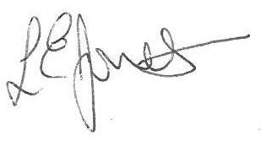

Louise Jones Sean Sly

Executive Head Acting Deputy Head





