
Weekly Newsletter
W.B. 8.9.25

A big welcome back to all children and parents! It has been brilliant hearing all of the amazing things that the children have got up to over the school holidays.
This week:

As part of English the children have been learning about the traditional tale Little Red Riding Hood. The children listened to the story and identified key features such as the characters, setting and main events. To support your child at home please can you ask them the following questions: Can you describe Little Red Riding Hood’s appearance? Where was Little Red Riding Hood going? What happened when Little Red Riding Hood was in the house? To support your child further it would be brilliant if you could read them the story.

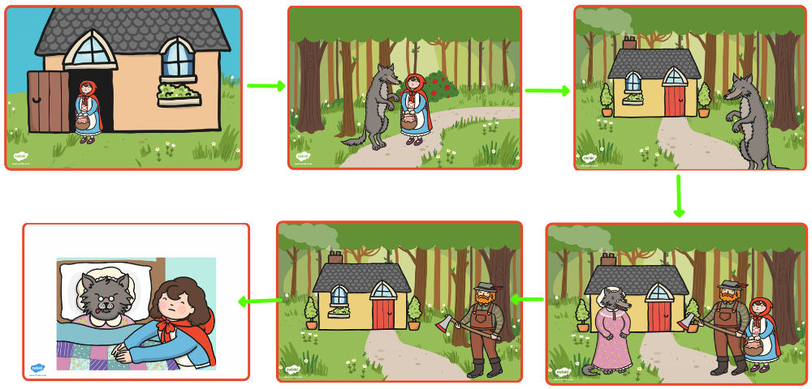

As part of Maths the children have been using Numicon to count forwards and backwards up to 100. They had lots of fun making different numbers using the Numicon pieces. Children also used the Numicon to explore the many ways they could make amounts using different numbers. Ask your child – how many different ways can you make 10?

At home please can you support your child with counting the amounts of objects and comparing which has the most and the least or equal amounts.

The children’s topic this half term is ‘Bounce’. As part of topic lessons children have continued completing art-based activities. They painted their own observational pictures of rugby and tennis balls and evaluated their art work.

We then started our Science learning. The children have explored touching a range of objects made from different materials before correctly sorting them into the correct material e.g. fork = metal
Can your child name some examples of materials? (metal, plastic, wood, glass)

Reminders:

PE
Class 7 PE day is Thursday.
Class 8 PE day is Thursday.
Class 9 PE day is Thursday.

Children must have the following in their PE bag: t-shirt, shorts, tracksuit bottoms, jacket, pumps or trainers and earrings removed or tapped on their PE day (this cannot be done by a member of staff).

Their kit must stay in school for the week in the event that the PE day needs to changes and / or a child has an accident so that we can change them into their own clothing so that they feel comfortable.

Class 7 Year 2s are swimming every Thursday until Thursday 13th November. Thursday 13th November will be class 7 Year 2’s last swimming session.
Class 8 and class 9 Year 2s will be swimming every Thursday from Thursday 20th November until the Thursday 29th January.

Attendance for KS1:
Class 7 – 99.3%
Class 8 – 100%
Class 9 – 99.3%

Homework
Homework will mainly be handed out on a Tuesday. On the odd occasion it may be on a different day due to timetable changes. Please return homework on a Monday. Handing it on a Monday gives you the opportunity before the weekend to ask the teacher any questions so that you are clear of how to support your child if unsure. There is a tray in each class where the homework needs to be returned. Please ask the teacher where this tray is if unsure.

Spellings
Spellings are handed out in phonics lessons every Thursday and your child will be tested on these spellings the following Thursday. Children will receive a list of spellings to practise each week. In addition to the spellings, children will be tested on a sentence containing the words. However, the sentence will not be sent home. This is to see if they can apply the spelling currently within their writing. Can you get your child to practise applying the words by creating their very own sentences?

Reading Diaries
Children in KS1 have all been provided with a Home Reading Diary. Please fill this in daily based on your child reading a couple of pages of a book or a whole book. Please return the Reading Diary to school each day and leave it in the designated classroom tray. There are books situated in the classroom for your child to take home when they have finished the book they are reading. Reading is extremely important to your child’s development so we really encourage your child to read a book or pages of a book daily. If you are unsure of your child’s reading book colour then please ask your teacher.

Online Safety
The Education for a Connected World framework is used by Royd Nursery Infant School to support in the delivery of online safety. It is a tool for anyone who works with children and young people. It enables the development of teaching and learning as well as guidance to support children and young people to live knowledgeably, responsibly and safely in a digital world.
It focuses specifically on eight different aspects of online education:
1. Self-image and Identity
2. Online relationships
3. Online reputation
4. Online bullying
5. Managing online information
6. Health, wellbeing and lifestyle
7. Privacy and security
8. Copyright and ownership
To view the document please click on the following link: https://assets.publishing.service.gov.uk/media/5efa05b4e90e075c5492d58c/UKCIS_Education_for_a_Connected_World_.pdf

Thank you
Miss Aldam, Miss Howes & Miss Payne

