
Weekly Newsletter
W.B. 15.9.25

This week:

As part of English this week the children have continued their first story writing genre of the year with Little Red Riding Hood. The children have generated some verbs (doing or being words) such as mumbled and bellowed. The children have also been writing simple sentences and some children have even been using the coordinating conjunction ‘and’ within their writing! A coordinating conjunction joins two simple sentences together.

Can your child explain what a verb is? (A doing word – jumping, knitting, went).
Can they generate a sentence about Little Red Riding Hood?

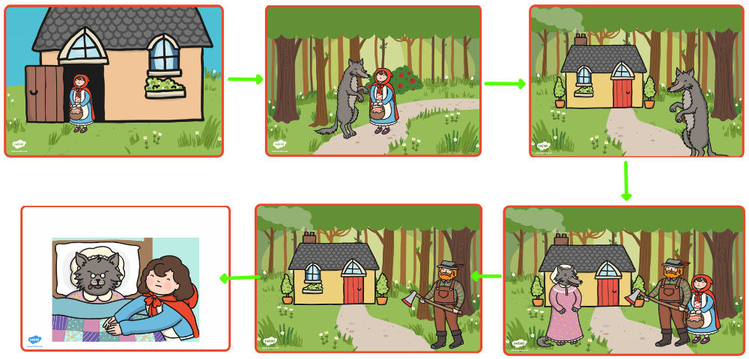

As part of Maths the children have been ordering groups of numbers given from smallest to largest and then form largest to smallest up to 100.

Can your child order the following numbers from smallest to largest and then from largest to smallest?

42 18 79
Remember to look at the tens first and then the ones!

Later on in the week, we looked at finding missing number on a numberline.

Can your child find the missing numbers on these numberlines?

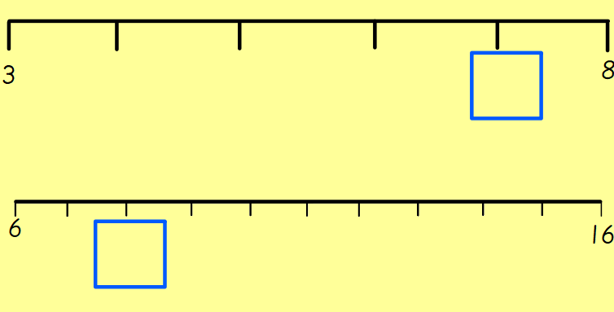

The children’s topic this half term is ‘Bounce’. As part of topic lessons children have continued their Science learning.

We have been looking at different materials (metal, wood, plastic, glass, fabric, rock) and their properties e.g. soft, hard, smooth, transparent, shiny, dull rough and smooth. The children then had to explain why certain objects are made out of specific materials e.g. a chair is made out of wood because it is strong and rigid. Gloves are made out of wool because wool is soft and it keeps our hands warm!

Can your child tell you the properties of wood? (hard, rigid)
Can your child tell you the properties of glass? (often transparent or translucent, brittle)
Can your child tell you why a water bottle is made out of plastic and not paper?

Reminders:
PE
Class 7 PE day is Thursday.
Class 8 PE day is Thursday.
Class 9 PE day is Thursday.

Children must have the following in their PE bag: t-shirt, shorts, tracksuit bottoms, jacket, pumps or trainers and earrings removed or tapped on their PE day (this cannot be done by a member of staff).

Their kit must stay in school for the week in the event that the PE day needs to changes and / or a child has an accident so that we can change them into their own clothing so that they feel comfortable.

Class 7 Year 2s are swimming every Thursday until Thursday 13th November. Thursday 13th November will be class 7 Year 2’s last swimming session.
Class 8 and class 9 Year 2s will be swimming every Thursday from Thursday 20th November until the Thursday 29th January.

Attendance for KS1:
Class 7 – 98.6%
Class 8 – 99%
Class 9 – 96%

Homework
Homework will mainly be handed out on a Tuesday. On the odd occasion it may be on a different day due to timetable changes. Please return homework on a Monday. Handing it on a Monday gives you the opportunity before the weekend to ask the teacher any questions so that you are clear of how to support your child if unsure. There is a tray in each class where the homework needs to be returned. Please ask the teacher where this tray is if unsure.

Spellings
Spellings are handed out in phonics lessons every Thursday and your child will be tested on these spellings the following Thursday. Children will receive a list of spellings to practise each week. In addition to the spellings, children will be tested on a sentence containing the words. However, the sentence will not be sent home. This is to see if they can apply the spelling currently within their writing. Can you get your child to practise applying the words by creating their very own sentences?

Reading Diaries
Children in KS1 have all been provided with a Home Reading Diary. Please fill this in daily based on your child reading a couple of pages of a book or a whole book. Please return the Reading Diary to school each day and leave it in the designated classroom tray. There are books situated in the classroom for your child to take home when they have finished the book they are reading. Reading is extremely important to your child’s development so we really encourage your child to read a book or pages of a book daily. If you are unsure of your child’s reading book colour then please ask your teacher.

Online Safety
The Education for a Connected World framework is used by Royd Nursery Infant School to support in the delivery of online safety. It is a tool for anyone who works with children and young people. It enables the development of teaching and learning as well as guidance to support children and young people to live knowledgeably, responsibly and safely in a digital world.
It focuses specifically on eight different aspects of online education. Strand 1 focuses on “Self-image and Identity”
To view Strand 1 “Self-image and Identity” please click on the following link and scroll to page 5 and 6 (if you would like to know more about this strand and what is covered from ages 7 – 18 please scroll to pages7 – 9):

https://assets.publishing.service.gov.uk/media/5efa05b4e90e075c5492d58c/UKCIS_Education_for_a_Connected_World_.pdf

Thank you
Miss Aldam, Miss Howes & Miss Payne

