
Weekly Newsletter
W.B. 22.9.25

This week:

As part of English this week the children have continued their first story writing genre of the year with Little Red Riding Hood. We have focused on writing different types of sentences including questions and exclamation sentences. A question is when we want a response or an answer from someone and we always end it with a question mark ‘?’ We came up with a range of question words we can use to start a question when we are writing including; who, what, where, why, when, how, do, which, can, is, are, were. Whenever we are writing an exclamation sentence it must include strong feeling or emotion and end with an exclamation mark ‘!’ For example, “Get out of my Granny’s house now!” yelled Little Red Riding Hood.

Can your child think of a question they would like to ask Little Red Riding Hood? Can your child tell you when an exclamation mark would be used and give an example?

We have focused on suffixes and looked at adding the suffix ‘s’ and ‘es’ which changes a root word to either plural or a present tense verb.

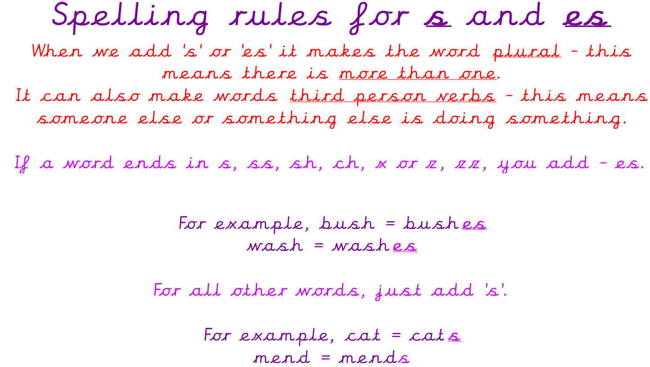

As part of Maths the children have applied their knowledge of ordering numbers to 100 to allow them to build 100 squares. The children had to count forwards and backwards from any number within 100 to locate and workout the missing numbers.
For example: 72 73 74 75 76 77 78

Can your child write the numbers that come before and after the number below?
___ ___ ___ 47 ___ ___ ___

The children’s topic this half term is ‘Bounce’. As part of topic lessons, children began their Design and Technology topic surrounding ‘Food and Nutrition’ where they identified healthy and unhealthy foods.
After identifying healthy and unhealthy foods, the children used the ‘eat well plate’ as a guide to create their own healthy plate which had to include 2 portions of fruit/ vegetables, 2 portions of carbohydrates, 1 portion of protein and 1 portion of dairy. We then looked in more depth at the five food groups: fat, protein, dairy, fruit and vegetables, carbohydrates and the children sorted food items into the correct categories on a food pyramid.

Can your child name some healthy and some unhealthy foods?
Can your children name the five food groups?

Reminders:
PE
Class 7 PE day is Thursday.
Class 8 PE day is Thursday.
Class 9 PE day is Thursday.

Children must have the following in their PE bag: t-shirt, shorts, tracksuit bottoms, jacket, pumps or trainers and earrings removed or tapped on their PE day (this cannot be done by a member of staff).

Their kit must stay in school for the week in the event that the PE day needs to changes and / or a child has an accident so that we can change them into their own clothing so that they feel comfortable.
Class 7 Year 2s are swimming every Thursday until Thursday 13th November. Thursday 13th November will be class 7 Year 2’s last swimming session.
Class 8 and class 9 Year 2s will be swimming every Thursday from Thursday 20th November until the Thursday 29th January.

Attendance for KS1:
Class 7 – 97.9%
Class 8 – 98.7%
Class 9 – 96.3%

Homework
Homework will mainly be handed out on a Tuesday. On the odd occasion it may be on a different day due to timetable changes. Please return homework on a Monday. Handing it on a Monday gives you the opportunity before the weekend to ask the teacher any questions so that you are clear of how to support your child if unsure. There is a tray in each class where the homework needs to be returned. Please ask the teacher where this tray is if unsure.

Spellings
Spellings are handed out in phonics lessons every Thursday and your child will be tested on these spellings the following Thursday. Children will receive a list of spellings to practise each week. In addition to the spellings, children will be tested on a sentence containing the words. However, the sentence will not be sent home. This is to see if they can apply the spelling currently within their writing. Can you get your child to practise applying the words by creating their very own sentences?

Reading Diaries
Children in KS1 have all been provided with a Home Reading Diary. Please fill this in daily based on your child reading a couple of pages of a book or a whole book. Please return the Reading Diary to school each day and leave it in the designated classroom tray. There are books situated in the classroom for your child to take home when they have finished the book they are reading. Reading is extremely important to your child’s development so we really encourage your child to read a book or pages of a book daily. If you are unsure of your child’s reading book colour then please ask your teacher.

Online Safety
The Education for a Connected World framework is used by Royd Nursery Infant School to support in the delivery of online safety. It is a tool for anyone who works with children and young people. It enables the development of teaching and learning as well as guidance to support children and young people to live knowledgeably, responsibly and safely in a digital world.
It focuses specifically on eight different aspects of online education. Strand 2 focuses on “Online relationships”
To view Strand 2 “Online relationships” please click on the following link and scroll to page 10 and 11 (if you would like to know more about this strand and what is covered from ages 7 – 18 please scroll to pages 12 – 14): https://assets.publishing.service.gov.uk/media/5efa05b4e90e075c5492d58c/UKCIS_Education_for_a_Connected_World_.pdf

Thank you
Miss Aldam, Miss Howes & Miss Payne

