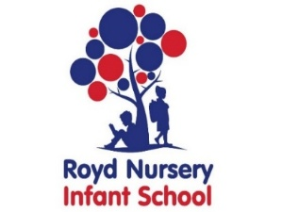
2 Year Provision September 2025

Name of Child :

Date of Birth:

Address:

Postcode:

Name of parent/carer:

Telephone :

Email:

Morning session 9.00 am to 12.00 pm
Afternoon session 12.00 pm to 3.00 pm
All day session 9.00 am to 3.00 pm

One session consists of 3 hours and is currently charged at £18.00*.
Mon AM | Mon PM | Tue AM | Tue PM | Wed AM | Wed PM | Thur AM | Thur PM | Fri AM | Fri PM

Currently, parents/carers for all 2 to 3 year-olds in England need to apply for funding via the Local Authority. To apply please go to https://www.sheffield.gov.uk/home/schools-childcare/childcare-free-early-learning/free-education-and-childcare-for-2-year-olds
Should you not qualify for funding, the three hour sessions are charged at £18.00 each*.

If you are eligible for funding, please complete the details below. Thank you.

Name of Parent _____________________________________________

Date of Birth

National Insurance Number

Funding Authorisation Code (if applicable)

* price correct at the time of printing

