

Royd Nursery Infant School

Carr Road, Deepcar

Sheffield, S36 2PR

Tel 0114 288 2594

Email royd.[enquiries@deepcarprimarypartnership.co.uk](mailto:enquiries@deepcarprimarypartnership.co.uk)

[www.roydnurseryinfants.co.uk](http://www.roydnurseryinfants.co.uk)

Executive Headteacher: Louise Jones

6 October 2025

Dear Parent/Carers,

Parents Evening for Reception, will take place on the following dates:

* Monday 10 November 2025 3.30 pm to 5.50 pm
* Thursday 20 November 2025 3.30 pm to 5.50 pm

Parent/carers will be able to come into the classroom for their appointment. The procedure will be for parent/carers to arrive outside your child’s classroom door, via the main school gate two minutes before the appointment time. The teacher will then come out to collect you.

To ensure that everybody has a fair chance of booking an appointment, please complete the form overleaf indicating your preference and return the form by Tuesday 13 October 2025 at the latest and School will endeavour to meet your request. Please note, due to the volume of replies email requests will not be accepted.

Confirmation of appointment times will be sent the afternoon of Wednesday 22 October 2025 by email. Thank you

Yours sincerely,

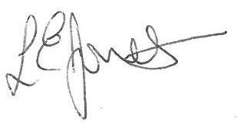

Louise Jones Sean Sly

Executive Head Acting Deputy Head







-----------------------------------------------------------------------------------------------------------------------------------------------

**Reception Parents Evening November 2025**

**Name of Child** : Class :

Monday 10 November between 3.30 pm and 4.50 pm

Monday 10 November between 5.00 pm and 5.50 pm

Thursday 20 November between 3.30 pm and 4.50 pm

Thursday 20 November between 5.00 pm and 5.50 pm