
Royd Nursery Infant School
Carr Road, Deepcar
Sheffield, S36 2PR
Tel 0114 288 2594
Emai:; royd.enquiries@deepcarprimarypartnership.co.uk
www.roydnurseryinfants.co.uk
Executive Headteacher: Louise Jones

6 October 2025

Dear Parents / Carers,

We would like to invite you in to School for a Nursery Stay and Play session with your child on
- Tuesday afternoon 18th November 2025
OR
- Friday afternoon 21st November 2025

There will be a range of activities where children will be able to explore our new termly topic ‘What is a Shadow’. The sessions will be from 1.40pm – 2.40pm.

Should your child not attend provision on Tuesday or Friday, parents/carers are welcome to join either session and school must be notified of the date you wish to attend. Your child must be accompanied by an adult due to ratio’s.

The stay and play session is a chance for parent/carers to be involved with their child during school time and therefore, siblings are not allowed at this activity. Please respect this request – thank you

Please complete and return the slip below if you would like to join us. It would be lovely to see you all.

Yours sincerely,
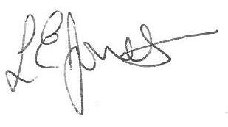

Louise Jones Sean Sly
Executive Head Acting Deputy Head

Nursery Provision Stay and Play November 2025

Name of child : Class FS1

Yes I / We would like to join you for the Stay and Play

Please select either 18th November OR 21st November

No I / We are unable to attend.

Signed ____________________________________________________ Parent/carer








