

Royd Nursery Infant School

Carr Road, Deepcar

Sheffield, S36 2PR

Tel 0114 288 2594

Emai:; royd.[enquiries@deepcarprimarypartnership.co.uk](mailto:enquiries@deepcarprimarypartnership.co.uk)

[www.roydnurseryinfants.co.uk](http://www.roydnurseryinfants.co.uk)

Executive Headteacher: Louise Jones

6 October 2025

Dear Parents / Carers,

We would like to invite you in to School for a Nursery Stay and Play session with your child on

* Tuesday afternoon 18th November 2025

**OR**

* Friday afternoon 21st November 2025

There will be a range of activities where children will be able to explore our new termly topic ‘What is a Shadow’. The sessions will be from 1.40pm – 2.40pm.

Should your child not attend provision on Tuesday or Friday, parents/carers are welcome to join either session and school must be notified of the date you wish to attend. Your child must be accompanied by an adult due to ratio’s.

Please complete and return the slip below if you would like to join us. It would be lovely to see you all.

Yours sincerely,

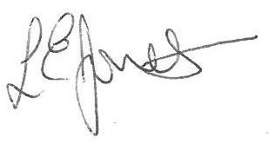

Louise Jones Sean Sly

Executive Head Acting Deputy Head

**Nursery Provision Stay and Play November 2025**

**Name of child : Class FS1**

Yes I / We would like to join you for the Stay and Play

Please select either 18th November **OR** 21st November

No I / We are unable to attend.

Signed ____________________________________________________ Parent/carer



