
Royd Nursery Infant School
Carr Road, Deepcar
Sheffield, S36 2PR
Tel 0114 288 2594
Email enquiries@royd.sheffield.sch.uk
www.roydnurseryinfants.co.uk
Headteacher: Louise Jones

18 November 2025

Dear Parent/Carers

The Choir has been invited to perform at Belmont Care Home on Tuesday 16th December after school. We need to know exactly which of the Choir children can attend, therefore, please could you complete and return the slip.

The plan is for the choir children to walk to Belmont Care Home after school with Miss Payne and Mrs Bradshaw and then perform some Christmas songs to the residents at around 4pm.

You will need to collect your child from Belmont Care Home at 4.30pm.


Belmont Care Home Address:

Belmont Drive,
Stocksbridge,
Sheffield,
S36 1AH

Please return the slip to School or email

Yours sincerely,
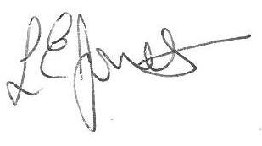

Louise Jones Sean Sly
Executive Head Acting Deputy Head
--------------------------------------------------------------------------------------------------------------
Choir at Belmont Care Home Tuesday 16 December 2025

Child’s Name: Class:

Yes, I would like my child to perform at Belmont Care Home

No, my child will not be attending

Signed …………………………………………………………….. Parent/Carer










