
Royd Nursery Infant School
Carr Road, Deepcar
Sheffield, S36 2PR
Tel 0114 288 2594
Email royd.enquiries@deepcarprimarypartnership.co.uk
www.roydnurseryinfants.co.uk
Executive Headteacher: Louise Jones

10 November 2025

Dear Parents/Carers,

On Tuesday 9 December 2025 the LINKs School Sports Partnership are running a Christmas Multi Skills Festival for children in Reception and KS1 (Y1 and Y2).

The event will be at Stocksbridge High School at 3.45 pm and finishes at 4.45 pm. Pupils need to wear a PE kit, suitable footwear and take a water bottle.

Please be aware that you will need to stay with your child and that School is not providing transport therefore, parents/carers will need to arrange travel for any child that wishes to attend.
If your child would like to attend, email Mrs Stuart on royd.enquiries@deepcarprimarypartnership.co.uk.

Thank you.

Yours sincerely,
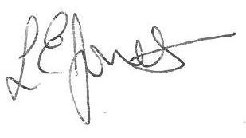

Louise Jones Sean Sly
Executive Head Acting Deputy Head











