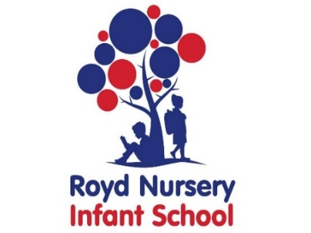
Royd Nursery Infant School
Carr Road, Deepcar
Sheffield, S36 2PR
Tel 0114 288 2594
Email royd.enquiries@deepcarprimarypartnership.co.uk
www.roydnurseryinfants.co.uk
Executive Headteacher: Louise Jones

19 November 2025

Dear Parents/Carers,

On Friday 12 December 2025 after school there is a Christmas party for the Reception children.

Children will be participating in activities that will be Christmas related including playing traditional games (eg musical statues), watching a short Christmas related movie and having their party food. The party finishes at 4.20 pm and the collection of your child is from their normal classroom door.

If you would like your child to attend the cost is £5. Payment and consent is to be made via Parentpay. If your child has dietary requirements these must be stated in the notes section. Monies need to be received by 2pm Friday 28 November 2025 so that all supplies and food can be purchased in time for the party.

Thank you.

Yours sincerely,
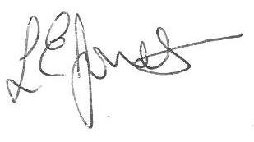

Louise Jones Sean Sly
Executive Head Acting Deputy Head











