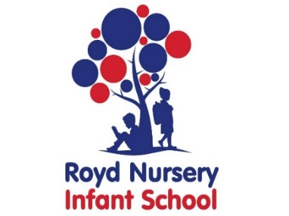
Royd Nursery Infant School
Carr Road, Deepcar
Sheffield, S36 2PR
Tel 0114 288 2594
Email royd.enquiries@deepcarprimarypartnership.co.uk
www.roydnurseryinfants.co.uk
Executive Headteacher: Louise Jones

11 November 2025

Dear Parent/Carers,

The Christmas concerts for the Foundation children (Nursery and Reception) will be on Tuesday 16 December 2025 and Wednesday 17 December 2025 at 10 am. Performances will take place in the main school hall. Younger siblings are welcome to attend but please be aware they will sit on your knee and not have a separate seat. May we kindly request that should siblings begin to make a noise please take them into the dining room at the back of the hall so children in the play are not distracted.

If your child attends nursery but not on the days and times of the allocated performances and you would like your child to take part, you will need to do the following:
- Advise Miss Musgrave or Miss Terry which performance you would like your child to be present for.
- On the day, bring your child with you for 10am where they will stay with you until the nursery children arrive in the school hall.
- Once the nursery children have settled, please take your child to the nursery staff.
- At the end of the performance and before the nursery children return to their classroom, please collect your child from a member of the nursery staff.
- This procedure ensures that we adhere to statutory ratios. Thank you

Entry to the show is free and we would really appreciate your support by purchasing raffle tickets on the day to help raise money for the School. If you have any items that you would like to donate for the raffle prizes please leave them in the School Office. Thank you.

Photographs are not allowed during the event. Individual photographs will be taken during dress rehearsal and sent home to parents/carers.

Families are limited to two tickets per child and will be allocated on a first come first served basis. The deadline for requests is 5 December 2025. If you would like to request an extra one or two tickets, please indicate on the return slip. The first extra ticket will be allocated on a first come first served basis and should there be further availability the same ruling will apply to the second extra ticket. Please be aware that, due to fire regulations, we have limited space and extra tickets cannot be guaranteed.

Due to the volume of requests expected, please do not email your request and use the reply slip. Thank you. We look forward to seeing you.

Yours sincerely,
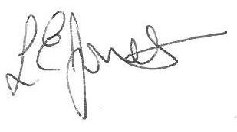

Louise Jones Sean Sly
Executive Head Acting Deputy Head


Royd Nursery Infant School
Carr Road, Deepcar
Sheffield, S36 2PR
Tel 0114 288 2594
Email royd.enquiries@deepcarprimarypartnership.co.uk
www.roydnurseryinfants.co.uk
Executive Headteacher: Louise Jones

Nursery and Reception Christmas Concerts 2025

Child’s Name : Class :

- Please request number of tickets.

Tickets for 10 am performance on Tuesday 16 December 2025

Tickets for 10 am performance on Wednesday 17 December 2025

Families are limited to two tickets per child and will be allocated on a first come first served basis.

If you would like to request an extra one or two tickets, please indicate on the return slip. The first extra ticket will be allocated on a first come first served basis and should there be further availability the same ruling will apply to the second extra ticket. Please be aware that, due to fire regulations, we have limited space and extra tickets cannot be guaranteed.

