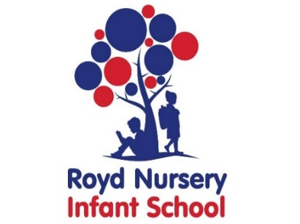
Royd Nursery Infant School
Carr Road, Deepcar
Sheffield, S36 2PR
Tel 0114 288 2594
Email royd.enquiries@deepcarprimarypartnership.co.uk
www.roydnurseryinfants.co.uk
Executive Headteacher: Louise Jones

4 November 2025

Dear Parent/Carers,

With the continued success of home school reading records School will be continuing with the diaries as children that had read regularly, made significant progress in their reading skills.

We wish to promote a love for reading and as a school we are determined that every child is able to read age related books fluently. School wants children to develop their vocabulary, comprehension (understanding) and a love of reading.

The Home School Record that your child is coming home with needs to be completed and returned on a daily basis as detailed below. Please return the home school record daily and place it in the tray specified by the teacher, allowing us to monitor your child’s reading. Your child can either take a book from the ‘going home books’ situated in each classroom or read books from home/Stocksbridge Library. Children can read a couple of pages or the whole book; this this can be done by your child reading to you, you can read to your child and then they read it back to you or read it together. These books would need to be changed by the child/parent/carers as part of the morning routine when coming in to the classroom. Please seek advice from the teacher if required.

Attached are some comprehension questions that Parent/Carers can ask while reading the book. Parent/Carers need to complete the date at the top of each page, write the title of the book under each day of the week, write a comment as to how your child has done in their reading/writing and then sign for each day.

Thank you for your support.

Yours sincerely,
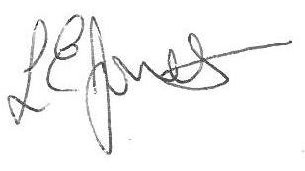

Louise Jones Sean Sly
Executive Head Acting Deputy Head



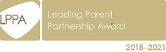



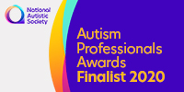



10 Benefits of Reading

1. Children who read often will widely get better at it.
After all, practise makes perfect in almost everything humans do, and reading is no different.

2. Reading exercises our brain.
Reading is a much more complex task for the human brain rather than watching TV, for example. Reading strengthens brains connections and builds NEW connections.

3. Reading improves concentration.
Children have to sit still and quiet so that they can focus on the story when they are reading. If they read often, they will develop the skill to do this for longer.

4. Reading teaches children about the world around them.
Through reading a variety of books children learn about people, places, and events outside of their own experience.

5. Reading improves vocabulary and language skills.
Children learn new words as they read. Subconsciously, they absorb information on how to structure sentences and how to use words and other language features effectively in their writing and speaking.

6. Reading develops a child's imagination.
As we read our brains translate the descriptions we read of people, places and things into pictures. While we are engaged in a story we are also imagining how a character is feeling. Young children then bring this knowledge into their everyday play.

7. Reading helps children to develop empathy.
As children develop they begin to imagine how they would feel in that situation.

8. Reading is fun.
A book or an e-reader does not take up much space and is light to carry. You can take them anywhere so will never be bored if you have a book in your bag.

9. Reading is a great way to spend time together.
Reading together on the sofa, bedtime stories and visiting the library are just some ways of spending time together.

10. Children who read achieve better in school.
Reading promotes achievement in all subjects, not just English. Children who are good readers tend to achieve better across the curriculum.

