2 Year Provision Newsletter – w/c 10/11/25
Last week
Welcome back after the half term break, we hope you had a lovely week!
Last week in our 2 year provision we have been learning about our new topic “ What Makes A Shadow” we have various resources in provsion to spark conversations around this.

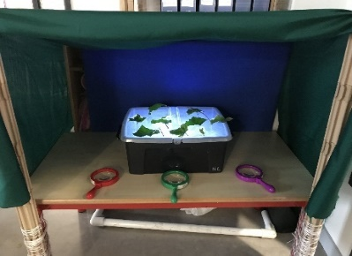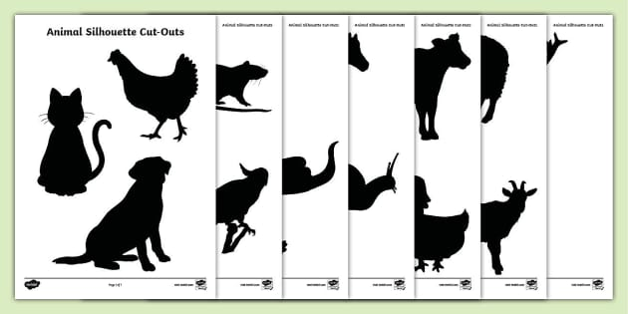

The children enjoyed exploring the various activities on offer. Making shadows using torches, matching silhouettes shapes to animals and creating silhouette pictures.
This week  We are continuing our topic What makes a shadow. The children will be exploring various activities around this.  We will also be celebrating Children in Need on Friday 14th November where children can come dressed up or wear pj’s and a donation of £2 can be made via just giving.   | Book of the week  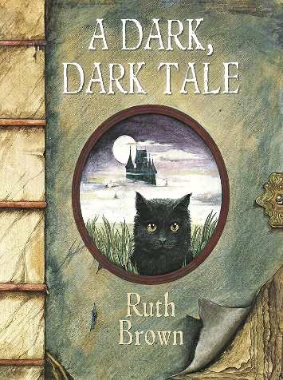  This story is linked to our current topic. Maybe if you have this story at home, you could look though the story together at bedtime.  
Dates for your diary
Parents evening – Monday 10th November
Remembrance Day 11th November
Children in Need- Friday 14th November
Parents evening – Thursday 20th November
Reminder
Please remember to ensure all your child’s clothing and water bottles are labelled and if you could provide spare clothes in their bag.

Now the weather is turning a bit cooler, can you please ensure your child brings a warm coat, hat, and gloves. We will be playing out in all weathers so if you would like to provide them with some wellingtons in labelled carrier bags as we have some large puddles which develop when it rains heavy and children love to jump in muddy puddles!

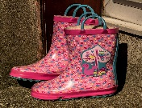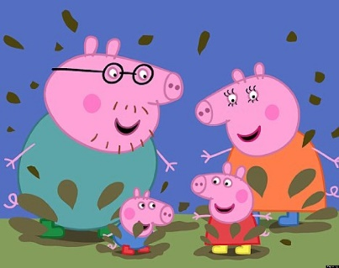
This Photo by Unknown Author is licensed under CC BY-NC-ND
This Photo by Unknown Author is licensed under CC BY-NC-ND



